Pre-lab Assignment – Tropical Communties

Name: __________________________________ 850_____________________________

Date: ______________________________________

All pre-labs need to be completed prior to coming to lab. You will hand these in to your TA before class. If you don’t complete the pre-lab assignment then you will NOT be allowed to participate that week's lab/field trip and you will receive a zero grade for that particular lab.

Please provide brief answers or calculations to the following questions in the space provided.
1. Explain the differences between octocorals and hexacorals (both morphological and in terms of function on the coral reef).

2. Define the following terms: theca, coenosarc, septa

3. Explain the mutualism between anthozoans and zooxanthellae. What does each player provide to its mutualist, and how does each benefit from the association? Are there any costs/penalties that the species incur as a part of the mutualism?

4. What species of parrotfish and predatory groupers did Mumby et al. study at ECLSP (give scientific names)?

5. How do the parrotfish species (and life stages) differ in their vulnerability to predation?

Lab Assignments

In your report, be sure to provide all of the necessary sketches and the answers to each question.

Objective 1: Identify corals of varying morphology
Background: Several specimens and photos of coral and algae have been provided by your lab instructors. These specimens represent both stony (scleractinian) and soft corals (non-scleractinian). They also represent reef-buiding (hermatypic) and non- reef building (ahermatypic) types. Not all hermatypic corals are scleractinian corals, and not all ahermatypic corals are non-scleractinian corals.
Today we will examine:
- Branching corals have branches that also have (secondary) branches.
- Digitate/Finger corals look like fingers or clumps of cigars and have no secondary branches.
- Plate corals have broad plate-like portions rising above the substrate.
- Encrusting corals grow as a thin layer against the substrate.
- Massive corals are ball-shaped or boulder-like corals which may be small as an egg or large as a house.
- Mushroom corals resemble the attached or unattached tops of mushrooms.
- Cup corals look like egg cups or cups that have been squashed, elongated or twisted
- Fire coral this hermatypic coral is a Hydrozoan, not Scleractinian. Note the very small pores, where tiny polyps protrude. The interior (where polyps are connected) is relatively hollow and the entire structure is very brittle.
- Gorgonians are ahermatypic octocorals. The colonies secrete a flexible proteinaceous endoskeleton.
Algae
• Calcareous green algae are common competitors of corals on reefs (and targeted by herbivores including parrotfish). The genera represented here are Halimeda and Penicillus. They have CaCO₃ impregnated in their cell walls to deter herbivory but are not hermatypic.
• Coralline red (branching & encrusting) are heavily calcified algae common on reefs. Encrusting coralline algae colonize empty reef space. Larval scelactinian corals often cue on chemicals released by these algae and preferentially settle on them.

Objective 1: Observe dead specimens
- Observe the specimens provided. For each specimen, 1. sketch the general morphology of the whole coral and 2. sketch a close-up on an individual polyp theca.
- Using your notes and the guides provided, for 4 different specimens list whether each is 1.Hexacorallia or Octocorallia, 2. scleractinian or 3. non scleractinian, 4. hermatypic or ahermatypic?
Objective 2: Observe living reef organisms
Background: Coral reefs are the most speciose and biodiverse marine habitat. Unfortunately we cannot take a field trip to observe natural coral reefs, but we can observe some reef organisms in pictures and video.
1. View all three videos linked on the lab website. For each video, use your knowledge from the nekton lab to describe what type of gait and swim style does each exhibit (e.g., BCF Carangiform, MPF diodontiform etc.), and what can you infer about their prey and feeding habits based on their mouth morphology? Describe their coloration. What do you think is the adaptive advantage of that coloration? Confer with your lab group about your interpretations.
2. View the three photos linked on the lab website. For each one, describe whether the coral species in the image (and there may be more than one coral species depicted) is hermatypic or not, and classify to the lowest taxonomic level possible. Guidebooks in the lab for Caribbean corals should be helpful.

Objective 3: Evaluate the relationships among common groups of Caribbean reef fauna to construct a food web. Predict the outcome of perturbations of that food web.
Background: Coral reefs are complex ecosystems controlled by biotic and abiotic interactions. Coral reefs are well known for intense levels of predation and competition for space. These ‘negative’ interactions (one side wins the other loses) drive adaptations for defense, prey capture, holding onto space and overgrowing others. Facilitative interactions are ‘positive’ interactions, where at least one side of the interaction benefits without harming the other, and can play a very important role in ameliorating stresses from competition or predation. Abiotic factors include storms such as hurricanes and nutrient run-off.
By understanding the how organisms interact, we can make predictions on how changes might affect the community. The following exercises will consider trophic cascades, or changes in a community brought about by changes in the dynamics of the food web. These cascades involve both direct predation as well as indirect effects on other species further down the food chain.
Trophic cascades can be diagramed using solid lines for direct interactions and dashed lines for indirect interactions. Use a positive or negative symbol to denote the type of interaction and point the arrow towards the organisms being affected. In addition, box size can denote relative abundance and arrow size or thickness can be used to denote strength of the interation.
For example, in the simple food web below, rabbits eat grass but they are also consumed by the bobcat. Mountain lions are an apex predator feeding on bobcats, which has an indirect benefit for the rabbit by removing its predator.

Bobcat
Rabbit
Grass
Mountain Lion
-
-
-

+

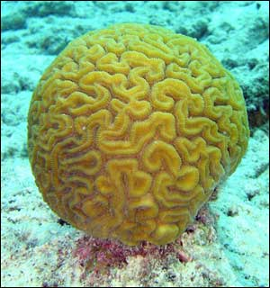 | Scleractinian Corals  Slow growing, these colonial organisms form the structure of reefs from their CaCO₃ skeleton. Coral polyps feed to feed on zooplankton, though they also get energy from symbiotic zooxanthellae which live in coral tissue.
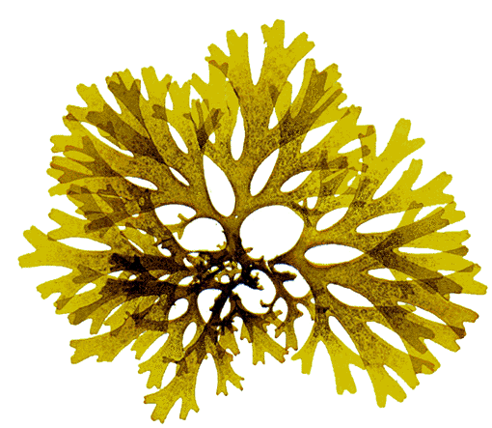 | Algae  Another member of the benthic community, macroalgae can grow much faster than corals, and can potentially smoother slow growing species.
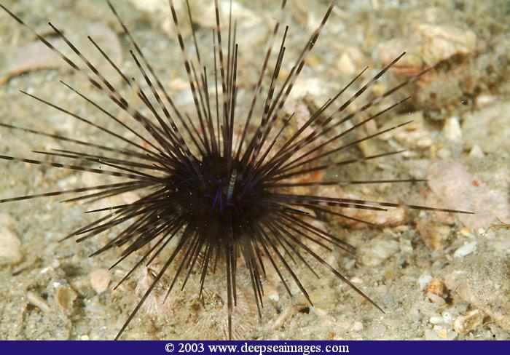 | Sea Urchin: Diadema antillarum  Diadema antillarum is a nocturnal herbivore that hides in reef crevices during the day.
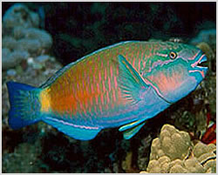 | Parrotfish:  With their “beak-like” jaw, parrotfish scrape algae off coralline rock, and can also consume coral polyps, sponges and other benthic species. Parrotfish rest in the crevices of the reef at night
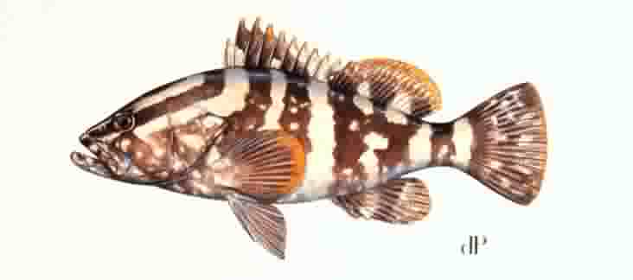 | Groupers:  A large predator, these fish travel the reef consuming smaller fish like parrotfish. Also, a tasty treat for people.

Procedure: Prior to arriving in lab, read the paper by Mumby et al. (2006), available on the course website. You will use that background information to answer the following questions with your group.
• Construct a food web that includes all the organisms listed above. Use solid lines to depict direct interactions and dotted lines to depict indirect interactions. Also, use (+) to signify positive interactions and (-) to signify negative interactions.
• Show how the food web would look on a heavily fished reef, and how Mumby et al. hypothesized it might change (and create a trophic cascade) inside no-take marine parks.
• In the 1980’s an epizootic disease killed nearly 100% of the black spined sea urchin, Diadema antillarium, throughout the entire Caribbean. What effect did this have on the trophic structure of the reef?
• What other changes to fishing regulations (aside from simply prohibiting fishing within a park like the ECLSP) might be helpful in boosting grazing rates on Caribbean reefs? Suggest at least one alternative.

