Prelab Assignment Lab 1: Properties of Seawater

Name:_____________________________ 850____________

Date:

All pre-labs need to be completed prior to coming to lab. You will hand these in to your TA before class. If you don’t complete the pre-lab assignment then you will NOT be allowed to participate that week's lab/field trip and you will receive a zero grade for that particular lab.

Please provide brief answers or calculations to the following questions in the space provided.

- What is a macro vs. a micronutrient? Which type is more applicable to measuring salinity?

- The ocean is not a static environment and surface waters are in constant interaction with the atmosphere where gases are exchanged. If surface waters are saturated with atmospheric gases, what do you expect the percentage of dissolved nitrogen, oxygen and carbon dioxide to be in seawater?

________% Nitrogen ________% Oxygen ________% Carbon dioxide

- List or diagram the main steps of the scientific method? What happens if the hypothesis is not supported? What happens if the hypothesis is supported?

- What is an equilibrium reaction? Provide an example.

- pH is a measure of how acidic a solution is at a given point in time and is calculated as follows:

pH = - log [H⁺]

where H⁺ is the concentration (M) of hydrogen ions in solution. In other words, it is the partial pressure of hydrogen ions in a fluid (hence the “p” in pH). Given the pH of seawater is about 8, what is the concentration of H⁺ in μM? Show brief workings (Hint: 1μM = 1 x 10⁻⁶M)

- What is a buffer? Why are buffers important in seawater?

Week 1 Lab – Properties of Seawater

Name:_____________________________ 850____________

Date:

Introduction

Seawater has several interesting characteristics that have biological consequences for the organisms in the ocean as well as Earth’s climate. Today we’ll be measuring several properties of seawater (and a few other fluids). This simple lab is designed to introduce or refresh your skills using basic laboratory equipment, some of which we will use repeatedly over the semester.

Learning Goals

By the end of the lab, students will be able to:
- Correctly use basic laboratory equipment and recent technology, including refractometer, hydrometer, pH meter, dissolved oxygen (DO) probes, and conductivity meter.
- Measure the temperature, pH, DO, density, salinity, viscosity, and conductivity of saltwater and other liquids, and characterize the relationships among those variables and how they relate to big picture concepts.

Procedure

Several stations will be set up around the lab at which you will measure some common properties of seawater or freshwater. Be sure to answer all the questions completely.

You may work in pairs or threes but please be sure to list all members of your working group on the assignment sheet.

Report

After completing this lab, you will prepare a report including answers to all questions, completed data tables, and graphs prepared in Excel, using the template included at the end of this document.

Station 1: Temperature

Temperature is proportional to the kinetic energy of the molecules in a substance. This property is fundamental to almost all biological, chemical, and physical processes and is one of the most common measurements made in marine biology. The SI unit for temperature is ºC.

Measure and record the temperature of various samples using the thermometers provided, then answer the following questions.
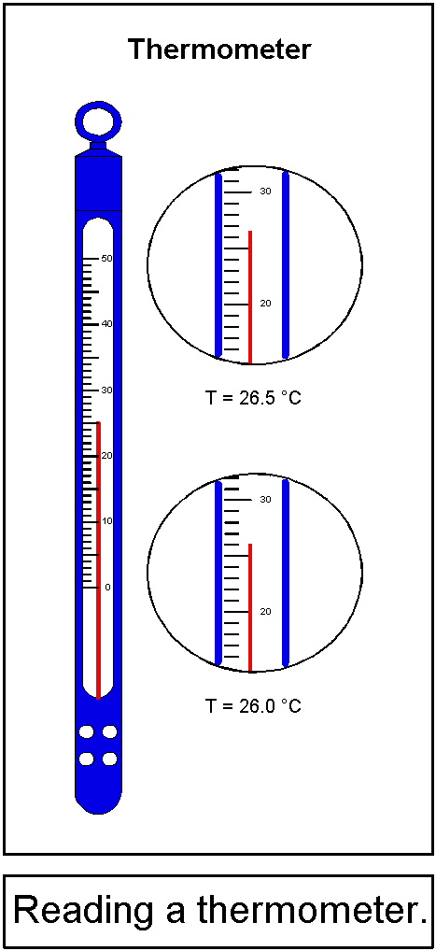
- What is the freezing point of seawater? How does this compare to freshwater?
- What is the boiling point of seawater? How does this compare to freshwater?

Sample | Temperature

Station 2: Salinity

Salinity is the measurement of the concentration of salt in a water sample. We will express salinity in units of parts per thousand (ppt, ‰). One way to measure salinity is to take advantage of the influence salinity has on the refractive index of water. The refractive index measures the angle by which light is bent when traveling from air into the liquid (think about what happens when a pencil is sitting in a half-full glass of water). Refractometers measure salinity by measuring the refractive index.

To use the refractometer: Rinse a pipette three times with a small portion of your sample, then rinse the refractometer three times as well. Finally, load a drop of sample onto the prism of the refractometer and close the translucent cover. Looking through the eyepiece at the scale on the right side of the measurement window, read the salinity of the sample at the junction of the light and dark portions of the view screen.

Sample | Salinity
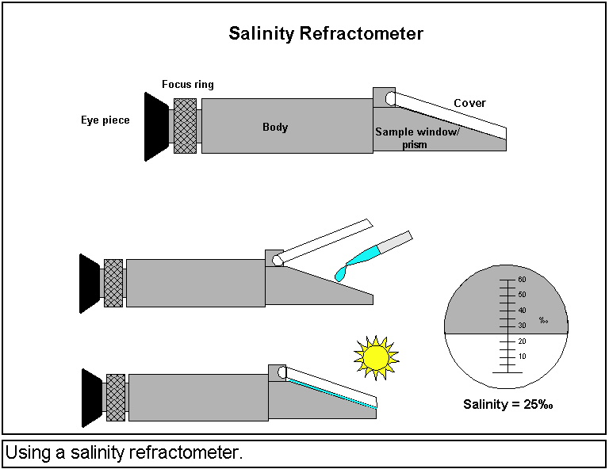

Station 3: Conductivity

Sample | Salinity | Temp | Conductivity
Pure water does not conduct electricity. However, when salts are dissolved in water the charged particles are capable of conveying an electrical current. The more salt, the more current transported. Conductivity is now the standard method for measuring salt content of seawater samples. The SI unit for conductivity is Siemens (S). Using the handheld conductivity meter and thermometer, measure the conductivity, salinity, and temperature of the sample, following the instructions provided. Note that the meter may report conductivity in different units (e.g., mS or µS) depending on the magnitude of the result. You may plot the results on the graph below to examine the relationship between conductivity and salinity for different temperatures. In your final report, you will plot your data in Excel.

Instructions for using the VWR conductivity meter

1. Ensure the meter is turned on; power button is in center at bottom of keypad.

2. Toggle the button in the middle of the right-hand side of the keypad (the button has 3 parallel bars on it) until the arrow is pointing at the conductivity measurements.

3. Toggle the up and down arrow buttons to get measurements in the desired units (conductivity will be in mS/cm or µS/cm; salinity will be in ppt).

4. Rinse the probe in DI water, then place in the sample.

5. Press the “measure” button in the upper right on the keypad (it has a picture of probe on it).

6. Gently swirl the probe in the sample to ensure a good reading. The measurement has stabilized when the units stop blinking. Once it stabilizes, the measurement of that sample will continue to be displayed on the screen even if you place the probe into a different sample.

7. Return the probe to the DI water to rinse it.

8. Repeat for additional samples.
Station 4: Density

Sample | Salinity | Temp | Density
Density is defined as the mass per unit volume. Dissolved salts and changes in temperature alter the density of a water sample. Freshwater is less dense than saltwater at a given temperature. Density of pure water increases with decreasing temperature until about 4 ºC, at which point the density decreases. For this lab we will be using the CGS (centimeter-gram-second) system of units, so density is reported as g cm⁻³ (instead of the base SI units, which would be g m⁻³). Determine the density of your samples by finding the mass of a known volume of the sample.
You may plot the results on the graph below to examine the relationship between density and salinity for different temperatures (you will obtain salinity and temperature measurements for each sample at Station 3). In your final report, you will plot your data in Excel.

Station 5: Specific Gravity

Specific gravity is the measurement of a liquid’s density relative to pure water at a certain temperature. Specific gravity is unitless. Measure the specific gravity of each sample using the hydrometer provided. Fill an appropriate cylinder with the sample and carefully float the hydrometer in the sample. Read the specific gravity directly from the scale on the hydrometer. You may plot the results on the graph below to examine the relationship between specific gravity and salinity (you will obtain salinity measurements for each sample at Station 3). In your final report, you will plot your data in Excel.
Sample | Salinity | Specific Gravity

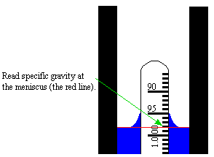

Station 6: Viscosity

Viscosity is the tendency of a fluid to resist flowing, or the internal stickiness of the fluid molecules. More technically, it is the resistance to the rate of shear in the fluid. Viscosity is important in the ocean for many reasons, including controlling the rate at which particles fall to the deep sea (called the biological pump) or the rate at which gases dissolve in sea water (see station 7), as well as how an organism receives nutrients or food to grow. The units for viscosity in SI is the pascal-second (Pa•s), which is equivalent to kg m⁻¹ s⁻¹, i.e., mass per length per time. We will be using a makeshift “falling sphere” viscometer to measure viscosity. This technique is based on Stokes’ equation for drag on a sphere at low Reynolds number (as we will discuss in lecture).

To make this measurement, fill a cylinder with a fluid sample and measure the time needed for a sphere of known density and size to fall a certain distance through the fluid (once it has reached a constant terminal velocity). Make several measurements and find the average velocity (distance traveled/time) of the falling sphere. Be sure to measure distance in cm using a ruler – the volume gradations on the cylinder do not necessarily correspond to distance units!

When an object is falling at a constant velocity through a fluid, the downward force from gravity is exactly balanced by the sum of the buoyant force from the fluid and the viscous drag of the fluid. As we will discuss in lecture, the net buoyancy force (upward buoyancy minus gravity) is proportional to the difference in density between the object and the fluid ( –  ₀) and the volume of the object:

where V is the volume of the object and g is the acceleration due to gravity (9.81 m s⁻²). For a sphere, this is:

where r is the radius. For spheres with very low Reynolds numbers, Stokes found that the usually very complex equation for the drag force could be simplified to:

where U is the terminal velocity of the sphere and  is the dynamic viscosity of the fluid. Because the drag must equal the net buoyancy force, it is possible to combine the above equations to solve for . This is known as Stokes’ Law, and states that viscosity () should be equal to

Replicate | Corn Syrup | Water
1
2
3
4
5
6
7
8
9
10
Average
Velocity
Viscosity

Parameter values:
r = 0.00225 m
g = -9.81 m s⁻²
ρ = 2200 kg m⁻³
ρ₀ = 1000 kg m⁻³ for water
ρ₀ = 1360 kg m⁻³ for corn syrup

Station 7: pH and buffers

pH is a measure of how acidic a solution is at a given point in time and is calculated as follows:

pH = - log [H⁺]

where H⁺ is the concentration (M) of hydrogen ions in solution (of course H⁺ does not exist freely in solution, it is in the hydronium ion H₃O⁺, but it is convenient to think about it this way). pH is measured on a scale from 1 to 14 with pH of 7 being neutral, pH < 7 being acidic and pH > 7 being alkaline or basic. Seawater has a pH of about 7.8 – 8.0 so it is slightly basic. One of the important properties of seawater is its buffering capability or its ability to resist a rapid change in pH. Seawater consists of many alkaline species such as metallic hydroxides (e.g., Barium, Sodium, Magnesium) that in solution supply OH⁻ ions that can react with protons (H⁺) to reduce any change in pH. pH and buffers are important properties when considering the effects of global change, in particular the increased dissolution of anthropogenic carbon dioxide from the atmosphere to the ocean. Carbon dioxide reacts with water to produce weak carbonic acid, which subsequently undergoes further equilibrium reactions depending on the pH, specifically to produce bicarbonate (HCO₃⁻) and carbonate (CO₃²⁻). Each step releases a proton. These inorganic carbon species are used by phytoplankton in photosynthesis and corals in constructing their exoskeleton, respectively. Increased carbon dioxide forces these set of equilibrium reactions to the left resulting in the water becoming more acidic, which impacts organisms that are made of carbonate (e.g. corals, oysters, coccolithophorids) by slowly dissolving them. Buffers in seawater slow down the rate of change. We will revisit this later in the semester both in lecture and lab but good to get a handle on this tricky concept early in semester.

For this lab, we will use the pH probe to measure how differences in buffering capabilities of fresh vs. seawater influences the rate of change in pH. We will add known quantities of carbonic acid to containers with water of varying salinities, and measure how the pH changes over time. For the report, you will plot results in Excel.

- Make up water in 4 treatment containers with the following salinities: 0, 10, 20, 30 ppt. The final volume should be the same between containers and no more than 500 mL. Mix each container thoroughly.
- Write your hypothesis about what you expect to happen with pH between treatments
- Take an initial readings for temperature, salinity and pH
- Add 100 mL of carbonic acid to each container, swirl so that the water is mixed, and take pH measurement
- Repeat step #4 five times until container is full
- Plot pH concentrations between salinities vs. volume carbonic acid added. Use the graph area if necessary.

What do the data say about buffering capabilities of seawater? Was your hypothesis supported?

Salinity | Vol Added | pH |  | Salinity | Vol Added | pH
0 |  |  |  | 10
Salinity | Vol Added | pH |  | Salinity | Vol Added | pH
20 |  |  |  | 30

Instructions for Thermo Scientific Orion pH meter

- Turn instrument on and gently remove probe from storage vial.
- Carefully wash probe with DI or MilliQ water, gently dry with tissue and replace on storage stand
- Calibrate with 4.0 (red), 7.0 (yellow) & 10.01 (blue) buffers. TAs will do this in advance of class. This will be done daily and the calibration slope should be > 97%.
- Carefully wash probe and gently dry
- Put sample container on stir plate and place 1/3 probe in water while holding. Gently move the probe back and forth in the sample.
- Select the “Measure (esc)” button. Display will say “stabilizing” and when stabilized will say “Ready”
- Note pH reading. Repeat steps 4-7 for remaining samples.
- Turn off stir bar.
- Carefully wash probe and gently dry. Replace probe in “Electrode Storage Bottle”, place on stand, and turn off pH meter
Station 8: Stratification
(adapted from Karp-Boss et al., Teaching physical concepts in oceanography)

Background:
Stratification refers to the arrangement of water masses in layers according to their densities. Water density increases with depth, but not at a constant rate. In open ocean regions (with the exception of polar seas), the water column is generally characterized by three distinct layers: an upper mixed layer (a layer of warm, less-dense water with temperature constant as a function of depth), the thermocline (a region in which the temperature decreases and density increases rapidly with increasing depth), and a deep zone of dense, colder water in which density increases slowly with depth. Salinity variations in open ocean regions generally have a smaller effect on density than do temperature variations. In other words, open-ocean seawater density is largely controlled by temperature. In contrast, in coastal regions affected by large riverine input and in polar regions where ice forms and melts, salinity plays an important role in determining water density and stratification.
Stratification forms an effective barrier for the exchange of nutrients and dissolved gases between the top, illuminated surface layer where phytoplankton can thrive, and the deep, nutrient-rich waters. Stratification therefore has important implications for biological and biogeochemical processes in the ocean. For example, periods of increased ocean stratification have been associated with decreases in surface phytoplankton biomass, most likely due to the suppression of upward nutrient transport (Behrenfeld et al., 2006; Doney, 2006). In coastal waters, where the flux of settling organic matter is high, prolonged periods of stratification can lead to hypoxia (low oxygen), causing mortality of fish, crabs, and other marine organisms.
Mixing of stratified layers requires work. As an analogy, think about how hard you need to shake a bottle of salad dressing to mix the oil and vinegar. Without energetic mixing (e.g., due to wind or breaking waves), the exchanges of gases and nutri- ents between surface and deep layers will occur by molecular diffusion and local stirring by organisms, which are slow, inef- fective modes of transfer. The energy needed for mixing is, at a minimum, the difference in potential energy between the mixed and stratified fluids. (Some of the energy, most often the majority, is lost to heat.) Therefore, the more stratified the water column, the higher the energy needed for vertical mixing.
Density is fundamentally important to large-scale ocean circulation. An increase in the density of surface water, through a decrease in temperature (cooling) or an increase in salinity (ice formation and evaporation), results in gravitational instability (i.e., dense water overlying less-dense water) and sinking of surface waters to depth. Once a sinking water mass reaches a depth at which its density matches the ambient density, the mass flows horizontally, along “surfaces” of equal density. This process of dense-water formation and subsequent sinking is the driver of thermohaline circulation in the ocean. It is observed in low latitudes (e.g., the Gulf of Aqaba in the Red Sea, the Gulf of Lions in the Mediterranean Sea) as well as in high latitudes (e.g., deep water formation in the North Atlantic). Within the upper mixed layer, convective mixing occurs due to heat loss from surface waters (density driven) and due to wind and wave forcing (mechanically driven).
Density is also fundamentally important to lake processes. As winter approaches in high latitudes, for example, lake waters are cooled from the top. As the surface water’s temperature decreases, its density increases, and when the upper waters become denser than the waters below, they sink. The warmer, less-dense water underneath the surface layer then upwells to replace the sinking water. If low air temperatures persist, these cooling and convective processes will eventually cool the entire lake to 4°C (the temperature of maximum density for freshwater at sea level). With yet further surface cooling, the density of the upper waters will decrease. The lake then becomes stably stratified, with denser water at the bottom and colder but less-dense water above. When surface waters further cool to 0°C, they begin to freeze. With continued cooling, the frozen layer deepens.
Instructions

A. Effects of temperature and salinity on stratification

- Fill a beaker with tap water.
- Place water from the beaker in one compartment of the tank and water from the salt-solution bottle in the other. Add a few drops of one food coloring to one compartment and a few drops of the other food coloring to the other compartment, and stir gently to mix them. What do you predict will happen when you remove the divider between the compartments? Explain your reasoning.
- Test your prediction by removing the tank divider. What happens?
- Empty the tank and fill one beaker with hot tap water and one beaker with ice-cold water. Add a few drops of food coloring to each of the beakers (different color to each beaker).
- Place the hot water in one tank compartment and the ice- cold water in the other. What do you predict will happen when you remove the divider? Repeat Steps 3–5. After removing the divider and observing the new equilibrium in the tank, place your fingertips on top of the fluid surface and slowly move your hand down toward the bottom of the tank. Can you feel the temperature change?
- How might the effects of climate change, such as warming and melting of sea ice, affect the vertical structure of the water column? Discuss possible scenarios with your group.
B. Effects of stratification on mixing

To prepare a tank with a two-layer stratified fluid, fill half of the tank with a strong saltwater solution (see Activity 1.4). Place a piece of thin foam (same width as the tank) over the water, and carefully pour tap water over the foam. When the tank is nearly full the foam will float to the top; take it off carefully without mixing the tank.
  - Prepare one tank with tap water and one with a two-layer stratified fluid (follow directions above).

  - Predict in which tank a dye introduced at the surface will mix more easily throughout the tank.

  - In the tank with the nonstratified water column, use the long pipette to carefully inject a few drops of food coloring at the water’s surface and a few drops of a different food coloring at the bottom of the tank. Using the hair dryer, generate a “wind” flowing roughly parallel to the fluid’s surface, and observe how the dye mixes. Use the hair dryer on the ‘low’ setting, and hold it about a foot away from the edge of the tank to create a moderate wind.

  - With the tank containing the two-layer fluid, use the long pipette to carefully inject a few drops of food coloring at the water’s surface and a few drops of a different food coloring at the bottom of the tank. Using the hair dryer, generate a wind similar to the one you generated in Step 3. Compare your observations to what you saw happen in the nonstratified tank. What do you observe about the depth of mixing of the surface layer, and the height of surface waves?

  - In light of your observations, predict and discuss with your group some potential effects of global warming on stratification and mixing in the ocean and in lakes. What might be some consequences for marine organisms?

Lab Report

Name:
Lab section:

Station 1: Temperature

Answer the following questions.
1. What is the freezing point of seawater? How does this compare to freshwater?

2. What is the boiling point of seawater? How does this compare to freshwater?

Station 2: Salinity

Report the results of your salinity measurements below.

Sample | Salinity

Station 3: Conductivity

Report the results of your conductivity and salinity measurements in the table. If necessary, convert the results to a consistent unit scale (e.g., mS). How do the salinity measurements differ from those taken at Station 2? (add more rows to the table as needed)

Sample | Salinity | Temp | Conductivity

In Excel, create a scatterplot of conductivity vs. salinity. Be sure to label axes and indicate units. Paste the graph below, and describe the relationship in 1-2 sentences.
Station 4: Density

Report the results of your density measurements in the table (along with salinity measurements from station 3). Add more rows as needed.

Sample | Salinity | Temp | Density

In Excel, create a scatterplot of density vs. salinity. Be sure to label axes and indicate units. Paste the graph below, and describe the relationship in 1-2 sentences.

Station 5: Specific Gravity

Report the results of your specific gravity measurements in the table (along with salinity measurements from station 3). Also, based on your results from stations 2-5, indicate which of the samples were likely to be DI water, tapwater, 100% seawater, 50% seawater, and 25% seawater.

Sample | Salinity | Specific Gravity | Identity

In Excel, create a scatterplot of specific gravity vs. salinity. Be sure to label axes and indicate units (where appropriate). Paste the graph below, and describe the relationship in 1-2 sentences.
Station 6: Viscosity

Stokes’ Law states that viscosity () should be equal to

In the table below, report your measurements of velocity, and calculate the viscosity of each fluid.

Replicate | Corn Syrup | Water
1
2
3
4
5
6
7
8
9
10
Average
Velocity

Station 7: pH and buffers

What were your hypothesis/es for what you expected the pH to do between different treatments?
Salinity | Vol Added | pH |  | Salinity | Vol Added | pH
0 |  |  |  | 10
Salinity | Vol Added | pH |  | Salinity | Vol Added | pH
20 |  |  |  | 30

What do the data say about buffering capabilities of seawater? Was your hypothesis supported?

Station 8: Stratification

1. What did you predict would happen when the solutions of different salinities and different temperatures were mixed? Did your observations match your predictions for each trial?

2. How might the effects of climate change, such as warming and melting of sea ice, affect the vertical structure of the water column?

3. What was your prediction for which tank would achieve greater mixing? What did you observe in each tank?

4. In light of your observations, what might be some potential effects of global warming on stratification and mixing in the ocean and in lakes? What might be some consequences of this for marine organisms?

