Self Checking Excel Spreadsheets
There are several uses for self checking excel spreadsheets. Some examples are practice sheets or picture labeling. This tutorial is only to show you how they work, you can modify it any way you choose. In this example we will create a self check practice for multiplication.

1. Open a blank excel document.
2. Into cell A1 type Question.
3. Into cell B1 type Answer.
4. Into cell C1 type Check It.
5. Into cell A2 type 3 x 4
6. Now the student will place an Answer in Cell B2, so let’s look at cell C2. Into cell C2 we will enter a “If” function.
7. Click on cell C2. Go to the insert menu and choose Function.
8. From the function list choose “If” and then click OK.
9. Into the Logical Function section enter the cell and answer. (Note – Numbers do not have quotes but words will require quotes.)
10. Into the Value if True box enter - Great Job or Fantastic
11. Into the Value if False box enter – Try Again or Not Yet
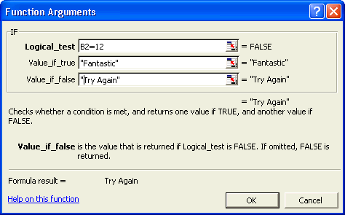
12. Now you can copy the formula in cell C2 and Paste it into C3, C4, etc. for as many cells as you want.
13. Then go back and type in the questions in the row A.
14. Now go down row C and click on each cell and change the answer to be correct for the corresponding cell in A. Be Sure to Press the Enter Key after Making Each Change!
15. Two notes: 1) If your answer is a word, be sure to put the word in quotes. Ex. Logical Test = “Red” . 2) Do not use True or False as answers. These confuse excel for some reasons. Instead use, Yes-No.

Conditional Formatting
Assembled by Jeff Ertzberger 2004 - UNCW
Once you have created the spreadsheet you can “liven it up” with some conditional formatting of the checking column.

Highlight a “check it” cell. Go to the Format Menu and choose conditional formatting.
Beside of the cell value is “equal to choose equal to” then type the words good job.
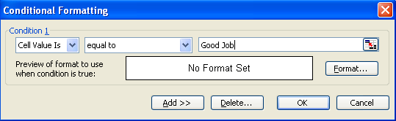
Click the format button and choose the style of the text, the shading for the cell, and the border if you want an outline around your text.
Next, click the Add>> button and repeat the above process, this time for the words try again.

Hiding the Checking Column
This leaves the “Great Job” or “Try Again” on the screen but doesn’t let the students see the formula which contains the correct answer.
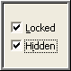
After you have set up and completed the spreadsheet.
1. First Hide the Formula - Highlight the checking cell
A. Go to the Format menu and choose Cells then click on Protection.
B. Be sure that the locked and hidden boxes are checked.
C. Choose OK.
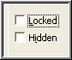
2. Next make sure the answer cells will work. Highlight the answer cell
A. Go to the Format menu and choose Cells then click on Protection.
B. Be sure that the locked and hidden boxes are NOT checked.
C. Choose OK.
3. Before it will work you have to turn on protection.
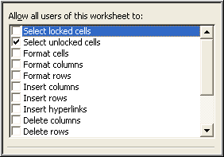
A. Go to the Tools menu, choose Protection, then Protect Sheet
B. Be sure only “select unlocked cells” is checked ( you can password protect this for extra protection.
C. To unprotect so you can edit it, go to the Tools menu, choose Protection and then Unprotect sheet.

