    - Problem Description

Write an application that accepts the unit weight of a bag of coffee in pounds and the number of bags sold and displays the total price of the sale.

2. Program Tasks

1. Gather input values: weight of a bag and number of bags sold
2. Calculate the cost of the sale
3. Output the sale details

3. Class Descriptions

CoffeeBag
A class that contains the number of bags sold and the size of the bags. This class also knows how much a bag of coffee costs and the sales tax and computes the totals for the sale.

Method | Visibility | Purpose
setUnitWeight | public | Set the weight for the bags
setNumberOfUnits | public | Set the number of units desired for the order
getUnitWeight | public | Get the weight for the bags
getNumberOfUnits | public | Get the number of units ordered
getPricePerPound | public | Get the price per pound of coffee
getSalesTax | public | Get the sales tax percentage
getSubtotal | public | Get the price of the order without tax
getTotalPrice | public | Get the price of the order including tax

CoffeeShipper
The main control class of the application. This class takes input from the user and displays the output after all calculations have been completed. This class contains only the main() method.

4. Program Diagram
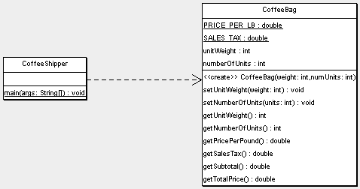

5. Design Discussion/Justification

The problem statement requires the use of the CoffeeBag class. Since that class contains the information about pricing and amount being ordered, all calculations are kept within it. The CoffeeShipper class provides the user interface and creates an instance of CoffeeBag to do the calculations specific to what the user requests.

