The following information is from :
http://japanese.about.com/blqow23.htm
It is very important to know stroke count and stroke order when writing kanji. The stroke count is the number of strokes used to write the kanji character. Both stroke count and stroke order help you to write a kanji character properly. The stroke count is also useful when using a kanji dictionary. The kanji for "mouth" looks like a square drawn with only one stroke. However the stroke count of this kanji is three.
The most basic rule for stroke order is that kanji are written from top to bottom and from left to right. Here are some other basic rules.
- Horizontal strokes are written from left to right and are parallel. (Example: the kanji character for "three")
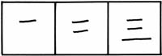
- Vertical strokes are written from top to bottom. (Example: the kanji character for "river")
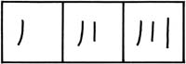
- When strokes cross each other, horizontal strokes are usually written before vertical strokes. (Example: the kanji character for "ten")
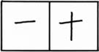
- Outside frames first, but bottom line last. (Example: the kanji character for "sun")
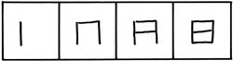
- Central vertical strokes are written last. (Example: the kanji character for "middle")
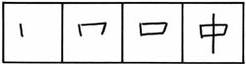
- Right-to-left diagonal strokes precede left-to-right diagonal strokes. (Example: the kanji character for "letter")
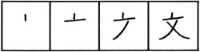
- Strokes which cut through the middle of kanji come last. (Example: the kanji character for "boat")
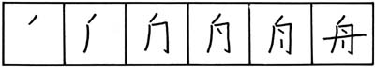
- There are three different endings: Stop, Stretch, Hook.
All kanji should be uniform size. If you want to master kanji, I suggest you put a lot of effort into writing kanji properly with the right stroke order from the beginning. Once you get bad habits, it is very hard to correct them later.
Click here for some kanji with animated stroke order.

