Design a Survey Form, Then Evaluate the Data Using Microsoft Access
Application: Microsoft Access 2000
Tip: Design a survey and evaluate the data.
Description: Design a survey that relates to your profession, and then they use the survey to interview a number of people. Once the surveys are completed, design a database to keep track of and analyze the data. Your survey is unique to other students’ survey.
How To:
- First, plan your survey fields and design the table.(first and last name, response(s))
- Specify the data type for each of your data fields
- Make your last name your primary key.
- Save your table then use your table to design your form
- Across the top of the survey form, type a title and any other heading you need, such as your survey question.
- Drag the table fields to your form design and edit your form design as appropriate.
- Save your form and have your classmates enter their responses into your form.
Tip: A table works well in a survey because often each question has a variety of choices. Look at the sample below, and try to integrate Word tables into your classroom survey as appropriate.
Sample survey question using a table (4 columns by 3 rows):
What is your favorite flavor of ice cream?
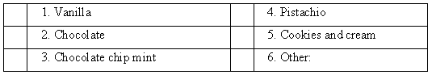
- Save and print your table and your form
- Create a web page based on your table/form so your data can be viewed via the web.
- Once the survey data is entered, use the Sort and Filter commands on the data to view different results of the survey. Try printing the different views of your data before removing any filters.
- Filter the data by form and filter the data by selection.(remember to remove your filters)
- Create a Data Access Page
- Create a query and add a calculated field (averages and percentages for each answer)
- Create a Report based on your query.
- Analyze your data with Microsoft excel (OfficeLinks menu) and create a chart of survey results

