Introducing Michaelis-Menten Kinetics Through Simulation
Christopher J. Halkides
Department of Chemistry and Biochemistry
University of North Carolina Wilmington
and
Russell Herman
Department of Mathematics and Statistics
University of North Carolina Wilmington
June 2005, Revised January 2006
Abstract
We describe a computer tutorial that introduces the concept of the steady-state in enzyme kinetics. The tutorial allows students to produce graphs of the concentrations of free enzyme, enzyme•substrate complex, and product versus time in order to learn about the approach to steady state. By using a range of substrate concentrations and rate constants, students are able to simulate enzyme kinetics and produce Lineweaver-Burk plots. The tutorial is intended for use in junior/senior level undergraduate biochemistry courses.

Introduction
The concept of the steady-state is fundamental to enzyme kinetics, in that the general derivation of the Michaelis-Menten equation assumes that the concentration of the enzyme•substrate complex has achieved steady-state (1). Moreover, an understanding of the steady-state facilitates an understanding of enzymatic isotope effects and enzymatic inhibitors (2). However, not all undergraduates have been exposed to the idea of the steady state prior to taking their first biochemistry course. This concept is made more pedagogically difficult by the fact that biochemists typically measure the "initial rate" of an enzyme catalyzed reaction, yet the rate that is measured is not strictly at time zero, but some number of milliseconds later, after the steady state has been achieved. Moreover, some students confuse graphs of appearance of product versus time ([P] vs. t) with graphs of velocity versus substrate concentration (d[P]/dt versus [S]), a Michaelis-Menten plot. More specifically, some students confuse the high [S] portion of a Michaelis-Menten plot (where the substrate S is saturating) with a graph of [ES] and [E] versus time in which the steady-state has been achieved. (See Figure 1.) To address these issues we created a computer tutorial that illustrates the meaning of steady state for the simplest possible case, that of an enzyme operating on a single substrate with three rate constants. (The tutorial can be found at http://people.uncw.edu/hermanr/TechFiles/mm/mm.htm.)

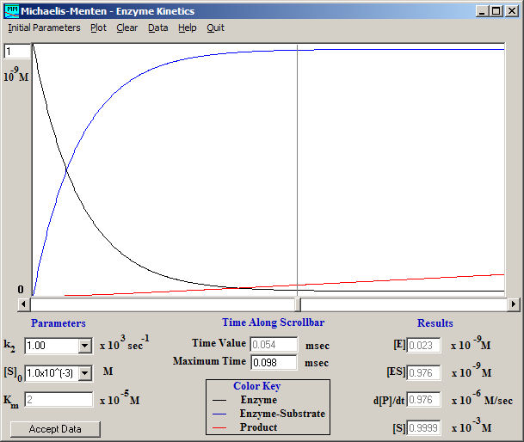
Figure 1 Sample plot in the Michaelis-Menten Program
showing the approach to steady state.

In lecture we introduce the Michaelis-Menten equation and graph before giving its derivation. We then discuss the concepts of the pre-steady state and the steady state in the classroom prior to students working through the tutorial. We do so by asking the students to imagine a dam with a flood gate across a river then to imagine how the rate of water passing over the dam changes with time (this analogy is briefly treated in the tutorial below). In addition, we stress that graphs of [E], [ES], and [P] versus time are very different from graphs of velocity versus [S]. However, even though some textbooks show graphs of [E] and [ES] versus t, the graphs are drawn at only one (implied) substrate concentration. Once the concept of steady state has been introduced graphically, we write equations for the rate of creation and destruction of the ES complex and an equation that define the steady state in this system:
$$d[\text{ES}]/\text{dt}=k_{1}[E][S]−k_{−1}[\text{ES}]−k_{2}[\text{ES}]=k_{1}[E][S]−(k_{−1}+k_{2})[\text{ES}]$$
$$d[\text{ES}]/\text{dt}=0$$
We provide a complete derivation of the Michaelis-Menten equation as part of a course pack that is similar to many textbook treatments. At this point the students are ready to undertake the tutorial.
We give the students a hardcopy of the tutorial and access to a computer on which this program and a spreadsheet program are loaded. Students are asked to choose a set of values of [S], and the tutorial produces corresponding graphs of [E], [ES], and [P] vs. time. The students are asked to find where the steady state begins by finding the place at which d[P]/dt is not changing to two decimal places, an admittedly arbitrary choice. Because students choose a variety of values of [S], the tutorial also demonstrates that the steady state is achieved at both high and low substrate concentrations, making the point that steady state and saturation are not the same thing.
As part of the exercise, students plot the velocities that they obtain versus their chosen [S] values in a spreadsheet program and obtain a standard Michaelis-Menten graph. They find values for Km and Vmax using a spreadsheet program to fit the Lineweaver-Burk equation. Although we acknowledge that the Lineweaver-Burk equation has shortcomings in the analysis of experimental data, we believe it is more practical for students taking their first biochemistry class to use linear regression than to learn and use nonlinear regression to fit the Michaelis-Menten equation. We introduce nonlinear regression in a subsequent laboratory/lecture course. The other drawback to the Lineweaver-Burk equation is that some students struggle to extract Km and Vmax from the slope and intercept of this plot. The determination of kinetic parameters might be especially useful for students who would not otherwise be exposed to saturation enzyme kinetics in a biochemistry laboratory class. Students hand in their work for a grade. They also complete a survey about the tutorial, which we discuss later. The survey is provided in Appendix B.
The graphs of concentration versus time are created from the solution of the Briggs-Haldane system of differential equations as described in the next section. Other authors have solved this system in different ways (3) (4). We have written programs in Visual Basic and Mathcad that solve and graph the appropriate equations. Although we have written a specific tutorial, the instructor may choose to write his or her own tutorial using this program. We recommend using the advanced tutorial for graduate students or exceptional undergraduates.

Theory
The Michaelis-Menten module was developed by using solutions to the underlying equations of enzyme kinetics under the assumption that the substrate concentration has quickly reached a constant value, [S] = s₀. In 1913 Michaelis and Menten (5) introduced the idea that an enzyme-substrate complex can form. Briggs and Haldane (6) introduced a more general formulation in 1925 (6). We will begin with the Briggs-Haldane system
$$\frac{d[E]}{\text{dt}}=(k_{−1}+k_{2})[\text{ES}]−k_{1}[E][S],$$
$$\frac{d[\text{ES}]}{\text{dt}}=k_{1}[E][S]−(k_{−1}+k_{2})[\text{ES}],$$
$$\frac{d[S]}{\text{dt}}=k_{−1}[\text{ES}]−k_{1}[E][S],$$
$$\frac{d[P]}{\text{dt}}=k_{2}[\text{ES}]\text{.}$$
This system models enzyme kinetics with an intermediate enzyme-substrate and three reaction rate constants, depicted by the reaction
By solving the Briggs-Haldane system under the assumption that the substrate concentration is constant, we can show that the time dependences of the other concentrations are given by
$$[E]=e_{0}τ[k_{−1}+k_{2}+s_{0}k_{1}e^{{−t}/τ}],$$
$$[\text{ES}]=e_{0}k_{1}s_{0}τ[1−e^{{−t}/τ}]\text{.}$$
$$[P]=e_{0}k_{1}k_{2}s_{0}τ[t+\frac{1}{τ}(e^{{−t}/τ}−1)]\text{.}$$
Here we have defined
One can then use these results to find the velocity, $v=\frac{d[P]}{\text{dt}}=−\frac{d[S]}{\text{dt}}$, as
Here we have defined and thinking of v as a function of s₀, the asymptote is defined as . Inverting this result leads to the Lineweaver-Burk equation:
.

Implementation
We provide the students with a printed version of the tutorial, which is also part of the module. We will run through a sample simulation to illustrate the use of the module. After a short introduction to the subject, the students pick a value of k₂ and vary the substrate concentration [S]₀, assumed to remain constant. This is reasonable since the substrate concentration typically reaches a constant level fairly quickly in actual experiments by the time data are collected. They then determine a time for which [ES] has reached steady state (to two decimal places). A typical display is shown in Figure 2. The concentrations at the selected time are easily saved when students select Accept Data.
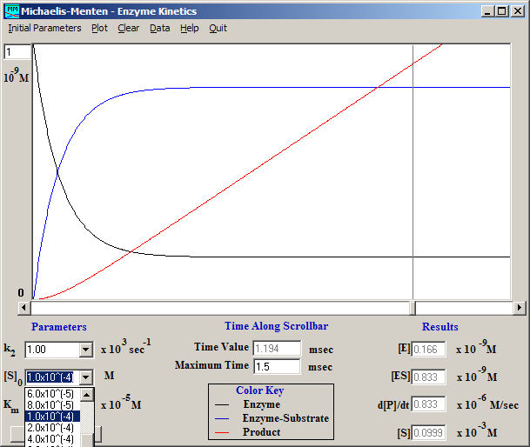
Figure 2 A typical plot for determining steady state. Also shown
is the selection process for the constant substrate concentration.

The stored data are then selected and copied into a spreadsheet program, such as Microsoft’s Excel. In the spreadsheet the student first makes a plot of velocity vs [S]₀. Such a plot is shown in Figure 3. From this plot students can determine the horizontal asymptote, V_{max}, and K_{m} as the substrate concentration which brings about a velocity equal to V_{max}/2.
Figure 3 Microsoft Excel spreadsheet showing a plot of velocity vs [S]₀.

However, it is easier to find these parameters using the Lineweaver-Burk equation. Recall, that this equation is given by
With this equation in mind, the students plot 1/v vs 1/[S]₀ and verify that the data yields a linear relation. Finding the best fit line, they can then obtain the intercept as 1/V_{max} and the slope as K_{m}/V_{max}. In Figure 4 we show what a student might obtain.

Figure 4 A typical Lineweaver-Burk plot in MS Excel based upon simulation data.

Students finish the tutorial by investigating the steady state aspects of the kinetics. For more advanced students the lab can be extended to the investigation of other values of k₂. They use this part of the study to test the assumptions made by Michaelis and Menten vs. those of the more general Briggs-Haldane formalism.

Classroom Observations and Survey
Some students attempted to fit a logarithmic function to the graph of velocity versus substrate concentration. There are several ways that the instructor can make this correction, depending on his or her evaluation of the level of mathematical background of the student. One is to note that the theoretical line does not fit well. Another is to note that the Michaelis-Menten equation is not written in the form of a logarithm. A third is to differentiate between functions with asymptotes versus functions without asymptotes. Some students might benefit from a numerical example of how to extract K_{m} and V_{max} from the slope and intercept of a Lineweaver-Burk plot.
Students’ perceptions and possible strategies based on them were determined using a class survey, which can be found at http://people.uncw.edu/hermanr/TechFiles/mm/mm.htm. Students were asked a number of questions after taking this tutorial. The first eight questions asked about the operation of the program and the appearances of the various plots. The questions were worded so that an answer of "agree" or "strongly agree" indicated that the program was working as expected. Students strongly agreed at least 56% of the time with the average being 64%. Questions nine through thirteen treated the concepts of enzyme kinetics. Here the average number of students who strongly agreed with the question was 44%. The responses indicated that the students had a better grasp of the term "steady state' than they did "saturation," a result which was unexpected. Some students expressed unfamiliarity with spreadsheet programs; therefore, the instructor may wish to make available a short set of instructions. One student noted that when large values of [S]0 are chosen, the Michaelis-Menten plot does not look exactly like the drawing in the tutorial. One student felt that part 4 might require further clarification.
The survey produced the lowest number of positive responses in questions fourteen and fifteen, the two questions covering the advanced tutorial, which touches upon the differences between the Briggs-Haldane versus the Michaelis-Menten derivations. Since this is a subtle point for most undergraduates, the survey results suggests that the instructor can direct students to ignore the advanced tutorial and focus on the basic one. One student described the program as a "definite asset." The present version of the tutorial attempts to address some of the issues that students raised in the survey.

Conclusion
The tutorial requires only a modest familiarity with computers and spreadsheets. Students appeared to have a better grasp of enzyme kinetics after the implementation of this tutorial than they did before. The determination of kinetic parameters might be especially useful for students who would not otherwise be exposed to saturation enzyme kinetics in a biochemistry laboratory class.

References

1. Segel, I. Enzyme Kinetics; Wiley-Interscience: New York 1975.
2. Raines, R. T.; Hansen, D. E. J. Chem. Ed., 1988, 65, 757-759.
3. Volk, L.; Richardson, W.; Lau, K. H.; Hall, M.; Lin, S. H. J. Chem. Ed., 1977, 54, 95-97.
4. Gellene, G. I. J. Chem. Ed., 1995, 72, 196-199.
5. Michaelis, L.; Menten, M. L. Biochem. Z., 1913, 49, 333-369.
6. Briggs, G. E.; Haldane, J. B. S. Biochem. J., 1925, 19, 338-339.
7. McDaniel, D. H.; Smoot, C. R., J. Chem. Phys., 1956, 60, 966-969.

Note: The tutorial and documentation are currently located at http://people.uncw.edu/hermanr/TechFiles/mm/mm.htm. However, we anticipate submitting the module and documentation to JCE Webware.

