- Step 1: Enter data in lists.
  - Push the STAT button.
  - Select EDIT and. Hit Enter to pick 1: Edit.
  - Enter x-values in to L₁ and y-values in L₂.
Note: If you need to clear out a list, for example list 1, place the cursor on L₁ then hit CLEAR and ENTER.
  - After the data is entered in the lists, push 2nd and then MODE to QUIT.
- Step 2: Plot the data on a scatterplot.
  - Hit 2nd and then Y= (This selects STAT PLOT and puts you in STAT PLOTS.)
  - Select 1: PLOT 1 and Hit Enter.
  - Use the arrow keys to move the cursor down to On and Hit Enter.
  - Arrow down to Type: and select the first graph under Type.
  - Other Selections (No action may be needed here.)
    - Under Xlist: make sure L₁ is entered here.
    - Under Ylist: make sure L₂ is entered here.
    - Under Mark: select any of these.
  - After you have set up the statplot, push 2nd and then MODE to QUIT.
- Step 3: Plot the points.
  - Hit ZOOM.
  - Select 9: ZoomStat and Hit Enter. The scatterplot will then be graphed.
- Step 4: Line of best fit.
  - Hit STAT, arrow over to CALC,and then
  - Select 4: LinReg(ax + b).
  - Hit Enter and then hit Enter again.
The value of a is the slope and the value of b is the y-intercept.
- Step 5: Find the correlation coefficient
  - The diagnostics must be turned on. Hit 2nd and 0.
  - Scroll down to DiagnosticOn.
  - Hit Enter and then hit Enter again
  - Repeat Step 4.
The correlation coefficient, r, will also be displayed with best fit line.
- Step 6: Plot Best Fit Line
  - You will select a y-variable in which to store the equation so you can see how the line fits the data. Make sure any previously entered equations have been cleared out.
  - Repeat Steps 4a and 4b
    - Hit STAT, arrow over to CALC,and then
    - Select 4: LinReg(ax + b).
    - Hit Enter.
  - Hit VARS.
  - Arrow over to Y-VARS and
  - Select 1:Function and Hit Enter.
  - Select one of the y-variables.
  - Hit Enter and hit Enter again.
The coefficients of the regression equation will appear and the equation will be in Y₁.
  - Hit the GRAPH button and the line that best fits the data will be graphed.

STAT MENU | LISTS | STAT PLOT MENU | PLOT 1 SELECTION | ZOOM MENU
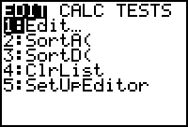 | 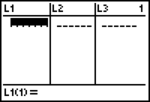 | 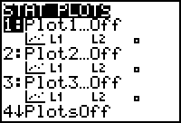 | 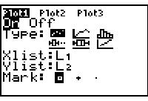 | 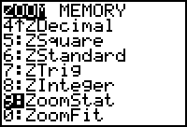
STAT CALC MENU | VARS MENU | FUNCTIONS | GET EQUATION | REGRESSION EQN
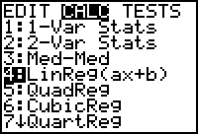 | 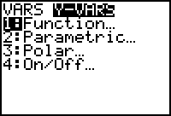 | 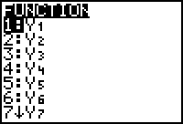 | 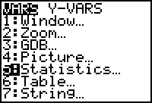 | 