Physics on a Rotating Space Station
For this project you will work in pairs to answer the questions below and to write your group report. All work should be typed with double-spacing and 12 pt font. You will be expected to use correct English grammar and punctuation. This includes using an equation editor for correct presentation of equations, including numbering. You will be graded on the evidence of work, mathematical detail and understanding, proper exposition and neatness. Your work should also be supported with properly labeled and embedded plots and/or sketches. Any references used should be cited as well. These reports will count 50 points towards the project component of your grade.
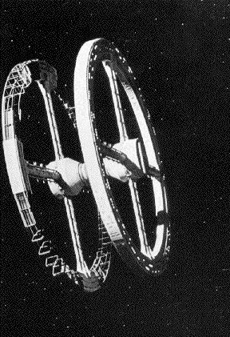

When one thinks about colonies in space, one typically thinks of a rotating space station. Such space stations have been popularized in science fiction, beginning with Arthur C. Clarke's 2001: A Space Odyssey in 1968. The earliest such designs have been attributed to O'Neill, who also provided designs for rotating cylinders, as opposed to the Clarke-Kubrick depiction of a rotating doughnut. The idea is simply that such rotating systems provide an artificial gravitational environment that is familiar to its inhabitants. However, there are some interesting consequences of living in such an environment. The purpose of this project is to explore some of the physics on a rotating doughnut shaped space station.

Let's consider a space station that is 160 m in diameter and 15 m wide.

- Considering that a typical house for a family of four is about 2000 sq. ft., how many people might this space station house?
- What would the period of revolution need to be to provide the typical 1.0 g of gravitational acceleration that we are used to on the Earth?
- What is the tangential velocity at the rim of the space station?
- How much faster would a space station of twice the diameter rotate?
- Standing on the rim floor, how far down the hallway could you see?
- Place a turntable (like an old phonograph record player) on the floor. Now place a pan filled with water on the turntable. Turn on the turntable, say at 78 RPM. Assume that the cake pan has a 40 cm diameter.
  - How fast is the water at the edge of the pan moving with respect to the floor?
  - How fast is the water at the edge of the pan moving with respect to the walls?
  - What is the overall difference in behavior?
  - Based upon your results with the spinning water, what do you think would happen if you spun a top on the floor?
  - Your sense of balance is based upon fluid in your ear canals. Assuming that you are looking spinward down the space station hallway. What would happen if you quickly turned your head clockwise? What if you were facing the wall and turned your head?
  - What would you experience, if any, if you were to jog down the hall with Dr. Lugo? (Such a jogging scene took place in the 2001 movie.)
- The force that you should have encountered in the last problem is called the Coriolis force. This force is also responsible for some other effects on the space station. Shuttle flights, delivering supplies and passengers to the space station, should dock at the hub for obvious reasons. Passengers and delivery personnel would get off at the hub and find a zero gravity environment. They then take an elevator to the rim, 80 m away. Let's assume that the elevator accelerates to 5.0 m/s in 2.0 seconds. It then travels at a constant speed for 14 seconds and decelerates to zero in the final two seconds.
  - What is the acceleration (radial and tangential) during the elevator ride?
  - Describe the effects of this ride on the passengers.
  - If a 90 kg person we riding the elevator on a scale, how would her weight change during this ride?
- Of course, living in the space station for long periods of time, the astronauts would need some recreation time. They could play racquet ball, squash, or ping pong.
  - From your previous observations, describe what you think projectile motion would be for an object (ball) thrown/hit up or down the long hallways of the space station.
  - In particular, describe the path of a ball dropped from a height of one meter from the floor.
  - Throw the ball horizontally and determine how long it is in the air, how far it was projected forward before hitting the floor and the path it followed.
  - What would a game of ping-pong look like? In what ways might you need to adjust your game?

