The Wheatstone Bridge

Purpose: To use a Wheatstone bridge to measure the resistance of several coils of wire and to determine the resistivity of copper.

Equipment: Slide wire bridge, Galvanometer, 40 ohm rheostat, set of coppers wire coils, decade resistance box, wire.
Discussion: The resistance of a wire of length L and cross section A is given as $R=ρ\frac{L}{A},$ where ρ is a proportionality constant called the resistivity. In this lab we will determine the resistance of four coils of copper wire and then determine the average resistivity of the set. We will a setup known as the Wheatstone bridge to determine the unknown resistance. Below are depicted the schematic and physical setup of such a bridge. One has a known, or standard, resistance R_{S}, and two lengths of wire, L₁ and L₂, whose total length is one meter and resistances are R₁ and R₂. The object is to determine an unknown resistance R_{X}. In this lab the unknowns are coils of copper wire.
The bridge works by adjusting the lengths of wire until the galvanometer reading is zero. This means that no current flows in the middle of the setup; therefore, the potential difference between points a and b is zero. Thus, the voltage drop across R_{S} is the same as that across R₁. Also, the drops across R_{X} and R₂ are the same. Using this fact, we can solve for the unknown resistance as shown to the right of the figures.

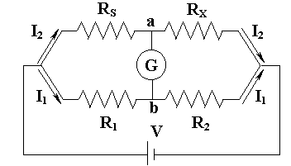 | Left side: $I_{1}R_{1}=I_{2}R_{S}$  Right side: $I_{1}R_{2}=I_{2}R_{X}$  Solve for R_{x}: $R_{X}=R_{S}\frac{R_{2}}{R_{1}}$
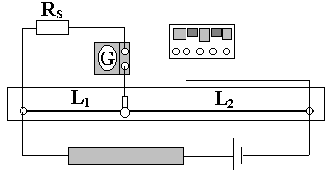 | Use equation for wire resistance $R=ρ\frac{L}{A}$: $R_{X}=R_{S}\frac{L_{2}}{L_{1}}$

Instructions:
- Set up the apparatus as shown above. Note that the rheostat is placed in the circuit to prevent the overheating of the wire. The standard resistance will be either a decade resistance box set to 1.0 ohm, or a 1.0 ohm resistor. Use the first coil of copper wire for the unknown. [Typically the standard resistor should be adjustable so that its resistance can be set near that of the unknown. This would place the contact switch in the middle of the wire and reduce the error in the length measurements.] Have the instructor check your setup before proceeding.
- Turn the power on and adjust it to about 2-5 volts. The galvanometer should deflect when you tap it onto the wire. Note: Do not hold the contact switch down while sliding it over the wire. Move the switch and locate the point at which there is no galvanometer deflection by tapping the switch. Record the lengths L₁ and L₂. [Be careful to determine which side is L₁!]
- Repeat the measurement for the other three coils of copper wire.
- Find the unknown resistances from your data.
- Use your resistances to compute the resistivity of copper for all four samples. Determine the average value of resistivity and compare it to the known value of $1\text{.}\text{72}´{\text{10}}^{−6}$Ω-cm. [ Note: The lengths and gauge of the wire is listed on the set of coils. For reference: 22 Gauge wire has a diameter of 0.644 mm and 28 Gauge has a 0.321 mm diameter.]

Data:
Table I: Computing Unknown Resistances
# | R_{S} (Ω) | L₁ (cm) | L₂ (cm) | R_{X} (Ω)
1
2
3
4

Table II: Computing Resistivities
# | Length (cm) | Diameter (cm) | Cross Section (cm²) | Resistivity (Ω-cm)
1
2
3
4

Average Resistivity ______________ Accepted Resistivity $1\text{.}\text{72}´{\text{10}}^{−6}$Ω-cm
Percent Error _________________

