Focal Length of Lenses

Purpose: To study the formation of images with thin lenses.

Equipment: Thin lenses (5 cm, 10 cm, -20cm), Meter Stick, Optical Bench, Object Light, Screen, Lens Holders.

Discussion:
In this lab you will study the formation of images from thin lenses. As shown in the figures below, there are basically two types of lenses, converging and diverging. Converging lenses are typically thicker at the center, which causes light rays entering one side to be refracted towards the axis from the other side. Diverging lenses, on the other hand, are thinner at the center and cause light rays to diverge after passing through the lens.

Each lenses has a focal length. In the case of a converging lens, parallel rays of light, or light which come from distant objects, will tend to focus at a point on the opposite side of the lens. This point is called the focal point and its distance from the center of the thin lens is called the focal length. For a diverging lens, parallel rays will pass through the lens and diverge from a point located on the object side of the lens. Therefore, the focal lengths of diverging lenses are negative.

The location of the image of an object can be determined using ray diagrams. For a vertical object, such as the arrows below, it is sufficient to locate the image of the tip of the arrow. Otherwise, we would need to locate the images of other points on the object. There are simple rules for determining the location of the image. These are listed next to the figures and the corresponding rays are shown passing through the lenses. In the examples shown, there is a real image formed with the converging lenses, but not with the diverging lens. Note: A real image is formed only if actual light rays converge to form the image.

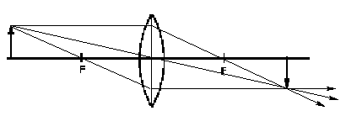 | Converging Lens $f>0$  - Parallel rays to the axis pass through the opposite focal point.  - Rays through the center continue in the same direction.  - Rays passing through the focal point emerge from the lens parallel to the axis.
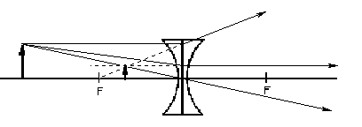 | Diverging Lens $f<0$  - Parallel rays to the axis diverge along a line passing through the focal point on the object side.  - Rays through the center continue in the same direction.  - Rays headed for the opposite focal point emerge from the lens parallel to the axis

We can also analytically determine the location of the image of an object for thin lenses by the lens equation. Let the object be located at a distance p from the lens (center), i the image distance from the center and f the focal length of the lens. These are related by the equation: $\frac{1}{p}+\frac{1}{i}=\frac{1}{f}\text{.}$
Note that the sign of f is important. Taking the object distance as positive, a positive image distance means that the image is on the opposite side of the lens.

Finally, the height of the image can also be determined. The ratio of the image height to the object height is called its magnification. This is given by $M\text{=-}\frac{i}{p}\text{.}$ The negative sign is introduced to account for any inversion of the image.

Instructions:
- Determine the focal length of both converging lenses by focusing a distant object on the screen. Record the 10 cm data as lens #1 and the 5 cm lens as lens #2.
- Since there is not real image formed from a diverging lens, you will need to tape one of the converging lenses to the diverging lens, creating a combination of two lenses, which are close together. The combination will have a total focal length given by $\frac{1}{f_{\text{comb}}}=\frac{1}{f_{\text{conv}}}+\frac{1}{f_{\text{div}}}\text{.}$ Use the 5 cm converging lenses, which is the thicker lens. You can then determine the focal length of the combination and solve for the focal length of the diverging lens, which is lens #3.
- Take the combined lenses in step #2 and use them to determine the location and height of the image of your illuminated object. Namely, set up the optical bench with the screen to light distance about five times the focal length of the lenses and the lenses between them. All objects should be the same height above the optical bench. Move the lens towards the screen and back it away until you get a sharp image. Record the object distance, the image distance and the heights of the image and the object.
- Repeat step 3 for the two converging lenses.
- Use one of the converging lenses as a magnifying glass. Place the lenses over an object, such as a book or piece of paper with writing on it. Move the lens closer and further from the object. Record what you see, such as the size of the object. Is it always inverted? Is the image always real?

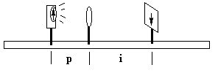

Data:

Lens | Focal Length (Object at Infinity) | Object Distance | Image Distance | Object Height | Image Height
#1
#2
#2 & #3

Analysis:

1. Calculate the focal lengths:

Lens | Focal Length
#1
#2
#2 & #3
#3

2. Compute the magnifications:

Lens | $$M=h_{i}h_{o}$$ | $$M\text{=-}ip$$ | Percent Error
#1
#2
#2 & #3

3. Ray Diagrams: On a separate piece of paper, neatly draw ray diagrams for the cases below. Use a sharp pencil and a ruler. Measure your distances accurately. Pick an appropriate focal length to draw your pictures.

- Converging lens with the object distance three times the focal length.
- Converging lens with the object distance half the focal length.
- Diverging lens with the object distance twice the magnitude of the focal length.

Case | Image Distance  Graphical | Image Distance Analytical | Percent Error
a
b
c

4. Magnifying Glass: Write a paragraph on your observations using a converging lens as a magnifying glass.

