Electromagnetic Induction

Purpose: To investigate electromagnetic induction in circuits, confirm Lenz's Law and to construct a transformer.

Equipment: Two coils, Galvanometer, Iron bar, Bar magnet, Diode, Function Generator, Connecting wire.

Discussion: According to Faraday's Law, a change in the magnetic flux in a closed loop will induce an emf in the loop. An induced current accompanies the induced emf. For a loop of area A in a uniform magnetic field, the magnetic flux is given as $F=B⋅A\text{.}$ Faraday's law can then be written as $E\text{=-}N\frac{\text{DF}}{Dt}$. The direction of the induced current is given by Lenz's Law: The current produced by the induced emf will be in a direction such as to produce a magnetic field, which opposes the change in magnetic flux.

In the second half of the lab you will be investigating the behavior of a transformer. A transformer consists of two coils. A change in the flow of current in the primary coil induces an emf in the secondary coil. In the lab you will use an alternating current; i.e., a current which continuously changes direction. This change can occur at a variety of frequencies, so you will also look at how the induced current depends upon the frequency of the current in the primary coil.

Instructions:

- Connect one coil to the galvanometer. Move the bar magnet toward and away from the coil and note the galvanometer deflection. Note the needle direction for each configuration. Use Lenz's law to explain the galvanometer deflection in each case.
- Move the magnet slowly toward and away from the coil in the last setup. How does the induced current depend on the speed of the magnet?
- Turn off the function generator. Connect one coil to the output of the generator and the other to the galvanometer in series with the diode. Place the coils on the table with their axes are aligned.
- Set the generator for 5-10 kHz signals and set the offset voltage to zero by centering the DC offset knob. Have your setup checked.
- Turn the gain all the way down and turn on the power supply. Slowly turn up the amplitude to get a deflection of the galvanometer needle, making sure that the needle does not jump too high. Adjust the DC offset knob to obtain the greatest deflection and then adjust the gain to get a reading of 500 μA when the coils are as close as possible.
- Carefully move the coils apart until the induced current is 400 μA. Measure and record this distance. Repeat for 300, 200 and 100 μA.
- Turn the gain to zero and the generator to 1 kHz. Put the coils together with an iron bar passing through their centers. Repeat the distance measurements, being careful to keep the bar centered between the coils.
- Move the coils back together with the bar inside. Note the current reading. Observe the response of the galvanometer to the following:
- Vary the frequency slowly from 1 kHz to 5 kHz and back.
- Remove the iron bar and observe what happens.

Data:
1. Lenz's Law observations:
Moving toward Coil: | 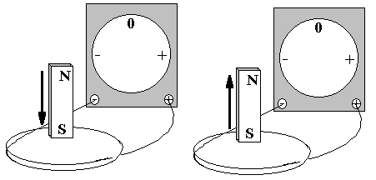 | Moving away from Coil:
Moving toward Coil: | 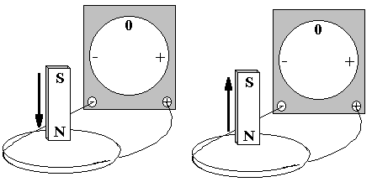 | Moving away from Coil:
- How does the induced current depend on the speed of the magnet? Is this consistent with Faraday's Law?

- Transformer I. Air-core

Current (μA) | 500 | 400 | 300 | 200 | 100
Separation (mm)

4. Transformer II. Iron-core

Current (μA) | 500 | 400 | 300 | 200 | 100
Separation (mm)

- Is there a difference in what you see in the two tables? If so, why is there?

- Observations on the frequency dependence. Note what you see from step 8.

