The Earth's Magnetic Field

Purpose: To determine the magnetic field at the surface of the Earth.

Equipment: Tangent galvanometer, D.C. Ammeter, Connecting wires, Ruler.

Discussion:
There is a magnetic field surrounding the Earth similar to that pictured on the right. At the magnetic north pole the field lines point in a vertical direction, while near the equator the lines appear to be parallel to the Earth's surface. In this lab we will determine the magnitude of the Earth's field in Wilmington. | 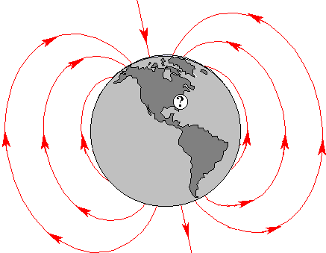
There will be two components. We will experimentally find the horizontal component of the field. When current i flows through a coil with N turns of wire and radius R, a magnetic field is created at the center of the coil with magnitude $B_{\text{coil}}=\frac{m_{0}\text{Ni}}{2R}$, where $m_{0}=4p´{\text{10}}^{−7}$T-m/A. When the current flows the compass will be deflect by an angle $q$ as shown in the figure. |  | 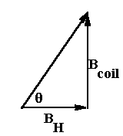$B_{H}=\frac{B_{\text{coil}}}{\text{tan}q}\text{.}$

The vertical component can be found from knowing the horizontal component and the dip angle, which is 58º in Wilmington, NC. The total field is the vector sum of these components. The figure to the right can be used to determine the vertical component form the horizontal component. It is then easy to get the local magnitude of the Earth's magnetic field. | 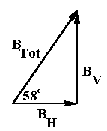$B_{V}=B_{H}\text{tan}\text{58}\text{.}$

Instructions:

- Measure the inside and outside diameters of the coil and determine the average radius.
- Set up the compass on the table as follows:
- Orient the plane of the coil in a true N-S direction.  - Turn the compass dial so that the wire indicator is approximately pointing to the zero marks. This will mean that the black compass magnet will be aligned with the plane of the coil.  - Note that the correct set-up has the coil and magnet aligned and falsely reading E-W when they are actually pointed N-S. | 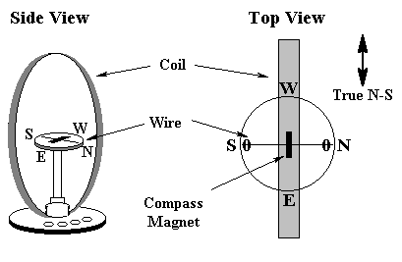
- With the power supply turned off, connect the tangent galvanometer to the power supply with the ammeter in series. Use the 10 turn connection on the galvanometer.
- Turn up the current until the angle is approximately 15 º. Record the readings from both indicator wires. Reduce the current to zero. Switch the leads to the galvanometer (not the power supply). Increase the current to the same current reading as before. Record these two additional readings. Average the four readings.
- Repeat step 4 for angles of 30º, 45 º and 60 º.

Data:

Radii:
Inside radius | Outside radius | Average radius

Dip Angle: 58 º

Angle (º) | Current (A) | Measured Angles (º) | Magnetic Field of Coil (Gauss) | Horizontal Field (Gauss)
15 º
 |  | Avg.
30 º
 |  | Avg.
45 º
 |  | Avg.
60 º
 |  | Avg.

Analysis:

Average value of horizontal component of Earth's field. ________________
Vertical horizontal component of Earth's field. ________________
Total magnitude of Earth's field. ________________

