Diffraction

Purpose: To study the diffraction of light through a diffraction grating.

Equipment: Meter Stick, Optical Bench, Laser, Lamp, Diffraction Grating, Lens Holders, Stands and clamps for light sources.

Discussion: In lecture you have learned, or will learn, that light passing through a narrow slit will produce an interference pattern known as a diffraction pattern. When monochromatic light is incident on a set of multiple slits, such as you have in a diffraction grating, the diffraction pattern appears as a well defined set of narrow maxima separated by large dark regions. In this lab, we will use a diffraction grating to determine the wavelengths of several sources of light.

As depicted below, the location, D, of these maxima depends on the wavelength of the light, λ, the slit width, d, and the distance that the grating is from the observation point. The angle can be determined from $\text{tan}q=\frac{D}{L}\text{.}$ The relation between the angle, the wavelength and d is given by $d\text{sin}q=mλ,$ $m=0,1,2,\text{.}\text{.}\text{.}$ Corresponding to each order non-negative m there are two bright spots equidistant from the center bright spot.

In this lab, you will look at first (m=1) and second (m=2) spots to determine the wavelengths of the incident light using these formulae.

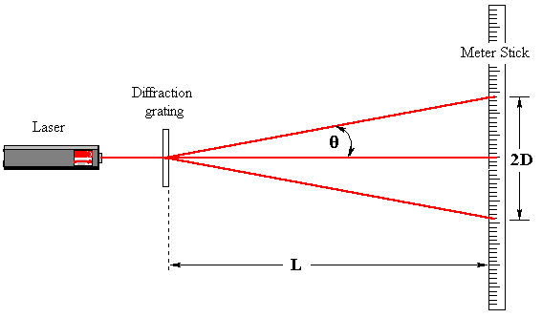
Instructions:
- Set up laser with the grating between the laser and meter stick. Be careful using the laser and do not look into it. Also watch out for reflected laser light. So, keep the laser light below everyone's eye level.
- Turn on the laser light and you should see first and second order spots appear on the meter stick. Adjust the stick so that the central spot appears about at the 50 cm mark. Record the positions of the first and second order spots in the Table.
- Measure the distance of the diffraction grating from the meter stick, L, and record it.
- Replace the laser source with the lamp. In this case you will only be able to see bands of visible light corresponding to the first order spectrum. Second order spectra are typically too dim to see.
- Note the order of the colors in the bands. Record the outer ends of the spectra. Namely, record the positions of the violet and red ends of the bands.
- For the four sets of data fill in the calculated values: Compute the difference between the left and righ readings. This is 2D. One can then get D by dividing by 2. The tangent of the angle is easily seen from the figure to be D/L. From this one can determine the angle and the sine of the angle. Finally, from the diffraction formula, the wavelength can be determined. Remember, the only case, which is not first order, is the second order laser data.

Data:

Number of lines per meter on the grating ___________________.

Grating constant d in meters ___________________.

Distance L from grating to meter stick (Laser) ___________________.

Distance L from grating to meter stick (Lamp) ___________________.

Source | Meter Stick Reading  Left Right |  | Calculated Values  Difference D tan θ θ sin θ λ % Error
Laser
(1 st Order)
Laser
(2nd Order)
Lamp (Violet)
Lamp (Red)

Your Range for Visible light ___________________.

Useful numbers: The wavelength of the laser light is 632.8 nm. The range of visible light is about 430 nm to 690 nm.

