Charging a Capacitor

Purpose: To study the charging and discharging of a capacitor.

Equipment: 800 μF Capacitor, 22 kΩ Resistor, Voltmeter, Shorting Bar, Stop Watch, Galvanometer, Power Supply.

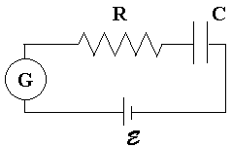
Discussion: In this lab we will verify the forms of the expressions for the current and the charge as functions of time for charging and discharging capacitors. We will use the RC circuit shown to the right. As a capacitor charges, the current flowing through the circuit decreases exponentially and the charge builds to a peak value [Figures 1a-1b]. When discharging, the current again starts out at some maximum value and decays as the charge on the capacitor diminishes[Figures 2a-2b]. The functions are given below, where τ = RC is called the time constant. Note that the sign on the discharging current only indicates direction of current flow.

Charging: | Discharging:
$$q=CE(1−e^{{−t}/{\text{RC}}})$$ | $$q=q_{0}e^{{−t}/{\text{RC}}}$$
Fig 1a | Fig 2a
$$i=\frac{E}{R}e^{{−t}/{\text{RC}}}$$ | $$i\text{=-}\frac{q_{0}}{\text{RC}}e^{{−t}/{\text{RC}}}$$
Fig 1b | Fig 2b

Instructions:
- Turn the power supply off. Plug the voltmeter into the power supply. Slowly turn the voltage up to 8.0 V making sure that the voltmeter needle is moving in the correct direction.
- Connect the elements the circuit except for the power supply. Identify the polarities of the electrolytic capacitor terminals for proper connection to the power supply. Test the stopwatch to make sure you can use the timer.
- Train the capacitor: Plug the capacitor into the power supply and let it charge for about 5 minutes. Carefully unplug the wires from the power supply and plug them into each other to let the capacitor discharge. When the current is close to zero, shunt the capacitor with the shorting bar. This will remove any remaining charge on the capacitor.
- Set the stopwatch to zero. You will have to plug in the power supply, start the stop watch and record the galvanometer readings simultaneously. [The needle will move quickly at first!] When you are ready to proceed, then plug in the power supply and start the stop watch when the needle drops to 300 μΑ. Record the times at 200, 100, 80, 60 and 40 μΑ in Table I.
- Let the capacitor continue to charge for 5 more minutes. Unplug the capacitor and start the stop watch when the needle drops to 300 μΑ. Record the times at 200, 100, 80, 60 ,40 and 20 μΑ in Table II. When the current is close to zero, shunt the capacitor with the shorting bar. Note: Do not shunt a fully charged capacitor!
- Repeat steps 4 and 5 three more times.
- Compute the average times for both tables. Plot graphs of the current versus the time. Find the best exponential fit to the data. In each case integrate the current to obtain the charge as a function of time. Note that initially there is no charge when charging and some maximum amount when discharging.

Exponential Fit:

In Excel one can do an exponential fit in a manner similar to doing a linear fit. The only difference is that you choose exponential when you format the trendline. In this lab you will be plotting the magnitude of the current versus the time. The data will look like the first graph of the current versus the time. Excel will give you an exponential of the form $y={\text{Ae}}^{\text{Bt}},$ where A and B are constants. In the example below, $A=\text{300} μA$and $B=−0\text{.}1 {\text{sec}}^{−1}\text{.}$
Comparing this expression with those for the current for charging and discharging: $i(t)={\text{Ae}}^{\text{Bt}}\text{.}$ Therefore, the charge as a function of time for charging is given by $q(t)=\frac{A}{B}(e^{\text{Bt}}−1),$ and that for discharging is given by $q(t)=\frac{A}{B}e^{\text{Bt}}\text{.}$ From these expressions, we find the time constant $τ=−\frac{1}{B}$ and the total charge $q_{0}=−\frac{A}{B}\text{.}$

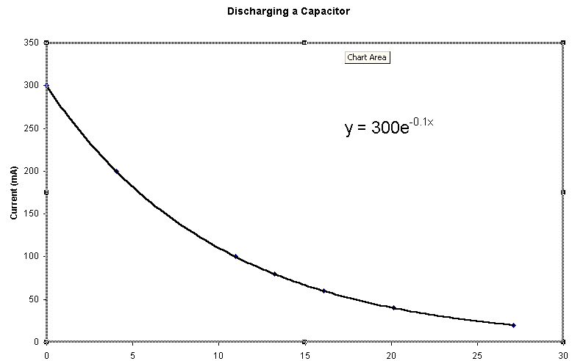
Data:
Capacitance __________________ Resistance __________________
Voltage __________________

Table I: Charging the Capacitor
Current (μA) | Time (sec) | Time (sec) | Time (sec) | Time (sec) | Ave Time (sec)
300
200
100
80
60
40

Table II: Discharging the Capacitor
Current (μA) | Time (sec) | Time (sec) | Time (sec) | Time (sec) | Ave Time (sec)
300
200
100
80
60
40

Record equations from graphs:
Charging: i(t) = __________________ Discharging: i(t) = __________________

Derive charge from the above equations for current:
Charging: q(t) = __________________ Discharging: q(t) = __________________

Total Charge: Using known values of C and E: ____________
From Charging: ____________ Percent Error: ____________
From Discharging: ____________ Percent Error: ____________

Time Constant: Using known values of R and C: ____________
From Charging: ____________ Percent Error: ____________
From Discharging: ____________ Percent Error: ____________

