Standing Waves on a String

Purpose: To investigate the relationship between the velocity, wavelength and frequency of waves in a string.

Equipment: Electric string vibrator, clamps and support rod, pulley with support rod, meter stick, weight hanger and standard masses, string, and balance.

Theory: Traveling waves are characterized by their wavelength $λ$ and frequency of oscillation f. These are related through the velocity of propagation of the wave v through the equation $v=fλ\text{.}$ It is easy to describe and visualize wavelengths. In the figure below the wavelength is defined as the distance between neighboring peaks. The height from the center is the amplitude of the wave. The frequency of a wave is similarly defined, except the horizontal scale is given in time. A simple way to describe the physical difference between wavelength and frequency is to imagine that you are standing in the ocean. The distance between successive wave peaks is the wavelength and the frequency is the number of wave crests per second which pass you. In the same way waves on a string can be produced, which may vibrate at the same frequency but with a variety of spatial wavelengths.
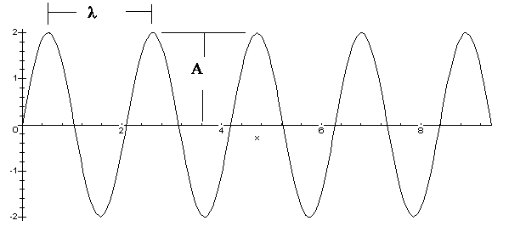.

Waves propagate through different media, such as strings and water at different rates, which depend upon the ability of the medium to deform. In the case of a taught string the wave velocity is given as $v=\sqrt{\frac{T}{m},}$ where T is the tension in the string and $m$ is it mass per unit length. In this lab we will use this expression to verify the relationship between the wavelength and frequency of standing waves.

When waves travel in a string fixed at one end, the waves reflect from that end and pass other waves on their return. The waves then interfere with each other due to the principle of superposition. If the waves reinforce each other they experience constructive interference. At such points the waves are said to be in phase and the resulting wave has a maximum amplitude. On the otherhand, there are places where the waves destructively interfere. In this case the amplitude is zero. The points of maximum amplitude are called antinodes and those of minimum, or zero, amplitude are called nodes. The distance between successive nodes, or antinodes, is half of a wavelength.

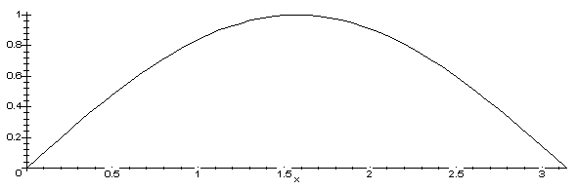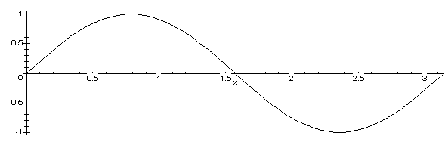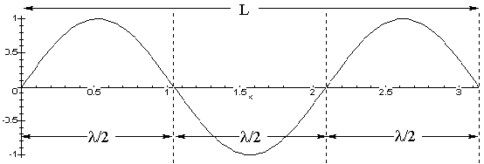
Fig 1. Fig 2. Fig 3.

In this lab you will create standing waves with several nodes. You can determine the wavelength for a given configuration very easily. For example, Figure 1 shows a half-wavelength. If the total distance shown is L, then the wavelength in this case is 2L. In Figure 2 the wavelength is L. In the last Figure the wavelength is 2/3 L. Continuing in this way we find a simple relationship between the length and the number of half-wavelengths, n: $λ=\frac{2}{n}L\text{.}$
In this lab you will be varying the tension in the string, keeping the frequency fixed. This will create waves with differing wavelengths, which you can determine by counting the number of half-wavelengths. The relation between the wavelength and tension is found from the velocity and frequency as $λ=\frac{1}{f\sqrt{m}}\sqrt{T}\text{.}$ Thus, a plot of $λ$ vs. $\sqrt{T}$ should yield a linear fit with slope of $m=\frac{1}{f\sqrt{m}},$ which can be solved for the frequency, $f=\frac{1}{m\sqrt{m}}\text{.}$
Instructions:

- Hang the weight hanger over the pulley with the string, which is attached to the vibrator.
- Plug the vibrator into the wall receptacle. If it vibrates loudly, then dampen the sound with the supplied rubber stopper or other object.
- Put enough weights on the hanger to produce a wave of one wavelength, like that in Figure 2. Note that the number of nodes decreases with increasing weights. Adjust the total weight to maximize the wave amplitude. This process is sensitive to within a few grams. Watch that the weights do not fall on your toes!
- Record the mass in the data sheet. Measure the length L, from the top of the pulley to the last node. This distance should be one whole wavelength, if done correctly.
- Begin to remove weights from the string to produce another node obtaining a wave like Figure 3 and the figure at the bottom of this page. Record the weight and distance. In this case, $L=\frac{3}{2}λ\text{.}$.
- Repeat the measurements to fill up the data table.
- Compute the wavelengths and the square root of the tension. In Excel plot the wavelength vs. the square root of the tension and determine the frequency from your slope.

Data:
Mass per unit length of string $1\text{.}\text{92}×{\text{10}}^{−4}$ kg/m

Number of Nodes | Suspended Mass (kg) | Tension (N) | Length (m) | Wavelength (m) | (Tension N)^{1/2}
2
3
4
5
6

Slope of the graph _______________

Frequency for Slope _______________

Accepted frequency 120 Hz
Percent Error _______________

