**In-Class Practice Problems (Chapter-6):**

1. 6.2.1 Use the reduction technique to find regular expression for the language of the NFA

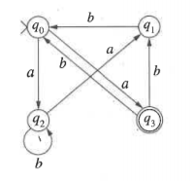

1. 6.3.1 Construct a NFA and give grammar for the language $a^{*}(a ∪b^{+})$
2. 6.3.3 Construct a grammar which generates strings over {a,b,c} which do not contain the substring abc
3. 6.3.4 Construct a grammar for the set of strings over {a, b} which generates strings with even number of a’s and odd number of b’s.