PAR 202 History of Western Philosophy II
Syllabus and Calendar  Introduction (ppt)  Giovanni Pico della Mirandola  Pico’s “Oration on the Dignity of Man”  Notes on Montaigne display | 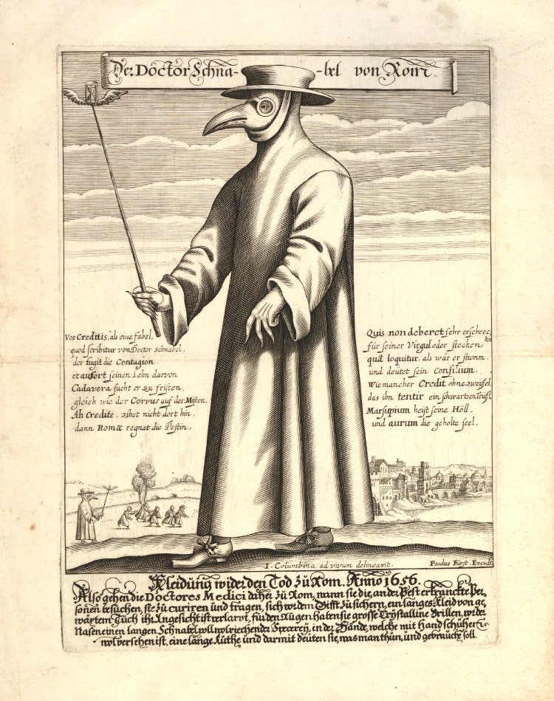

Return to Patricia Turrisi’s page.

