The Public School Forum’s Friday Report
PDF versions can be found at www.ncforum.org/archives.htm

Volume 5, Issue 15 November 14, 2003

2003 NAEP Results Released;
NC Performs Above National Average in Reading & Math

North Carolina 4th and 8th graders performed above the national average in reading and mathematics, according to the National Assessment of Educational Progress (NAEP) test results released by the National Center for Education Statistics. Prior to this year, NAEP was a voluntary assessment that states participated in as an education benchmark against other states. The No Child Left Behind (NCLB) legislation requires states to participate in NAEP, also called the Nation’s Report Card, to validate state progress because NCLB allows states to use state-approved assessments. The results are broken down by the performance categories of below basic, basic, proficient, and ad vanced; and NAEP’ s proficient level is higher than our state’s grade level proficiency.

Math Results

North Carolina’s 4th grade math performance was particularly notable, with 41% of North Carolina students scoring at or above proficiency, compared to the national average of 31%. The state’s 4th graders ranked third nationally in the percentage of students at or above proficiency. The North Carolina 8th grade proficiency performance was five percentage points above the national average (32% to 27%). This percentage is five points higher than in 2000 (the previous time NAEP was given) and 23 percentage points higher than in 1990 (see chart). The New York Times noted that “North Carolina showed the large st gain among students since 1992, with the share of students ranked proficient in math soaring to 41 percent from 13 percent in fourth grade and to 32 percent from 12 percent in eighth grade.”

North Carolina’s results were part of a pattern of strong performance across the region. At the press conference, John Stevens, a member of the National Assessment Governing Board, which oversees NAEP, noted the strength of Southern state-performance: “In math, the largest gains since 1990 and 1992 have been in some of the Southern states—North Carolina, South Carolina, Louisiana, and Mississippi. At eighth grade, Texas and New York are in this group too. In reading at fourth grade, where NAEP data goes back to 1992, the gains have been largest in Delaware, Florida, North Carolina, and Maryland. In eighth grade reading, where state NAEP goes back only to 1998, there are gains in only eight states. Most of these gains are pretty sm all, but half of the states that achieved them are in the South.”

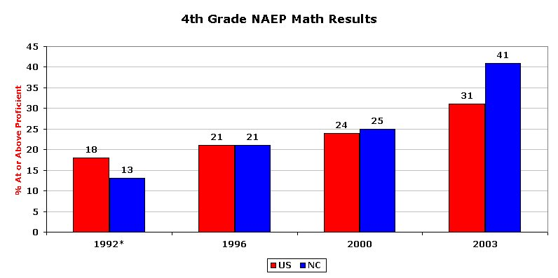
* Accommodations not permitted. Source: NCES, Nations Report Card

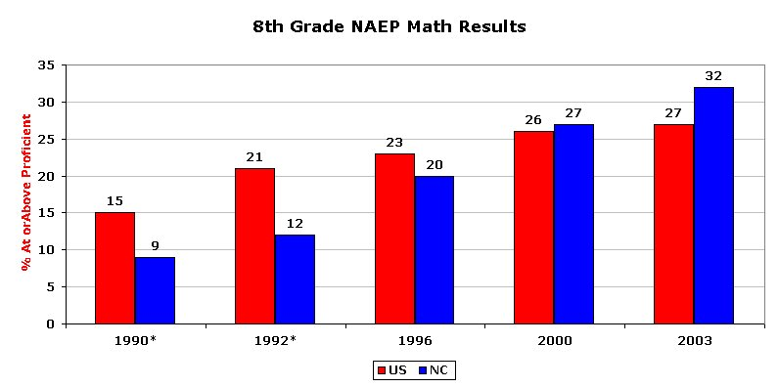

* Accommodations not permitted. Source: NCES, Nations Report Card

Reading Results

Thirty-three percent of North Carolina 4th graders scored at or above proficient in reading, compared with the national average of 30%. Eight percent scored at the advanced level, up from 5% in 1992 and slightly above the national average of 7%. In 1992, 25% of the state’s 4th graders scored at or above proficient (see chart). North Carolina fourth graders, along with Delaware, Florida, and Maryland, had the largest gains.

The state’s 8th grade proficiency performance was slightly below the national average (29% to 30%). According to NCES, “the percentage of students in North Carolina who performed at or above the NAEP Proficient level was 29 percent in 2003. This percentage was not found to be significantly different from 2002 (32 percent), and was not found to be significantly different from 1998 (30 percent).”

As with math results, North Carolina’s performance was noted by Stevens: “In reading at fourth grade, where NAEP data goes back to 1992, the gains have been largest in Delaware, Florida, North Carolina, and Maryland.”

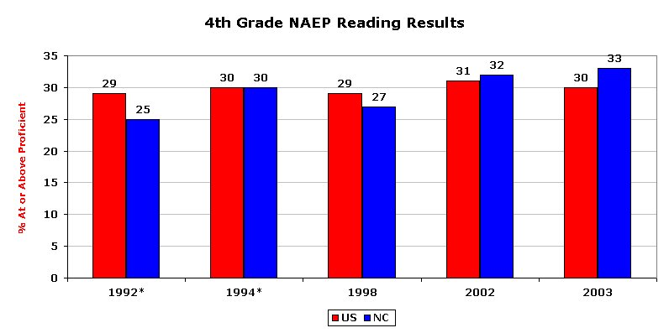
* Accommodations not permitted. Source: NCES, Nations Report Card

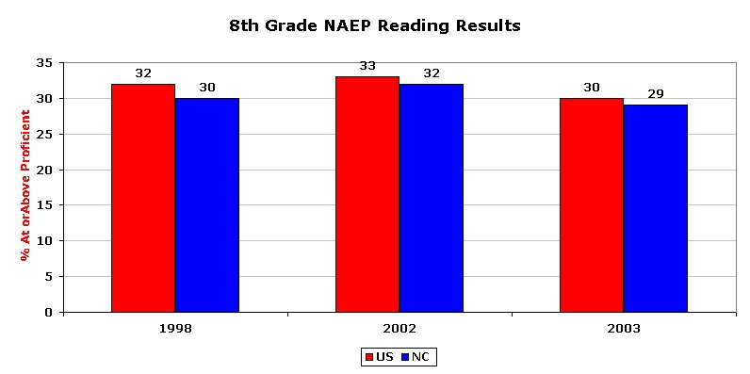

* Accommodations not permitted. Source: NCES, Nations Report Card

editor’s note: Next week’s Friday Report will have more extensive analysis of disaggregated data.

For a copy of the full report, go to http://nces.ed.gov/nationsreportcard/

State News . .

