% of Secondary School Graduates Who Ranked Below an International Literacy Standard

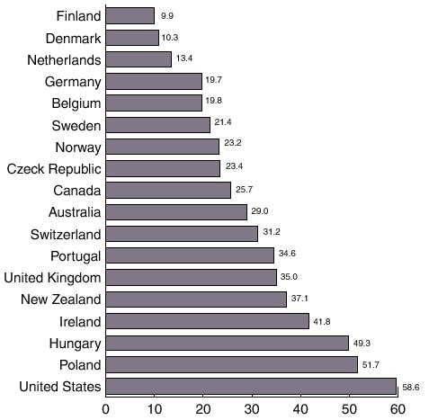

Source: Organization for Economic Cooperation and Development, 2001

The study looked at scores from 16-25 year old high school graduates, excluding individuals who go on to further education. The measure of literacy was defined as having the skills/knowledge necessary to cope with the “complex demands of modern life.” Education Week April 4, 2001.

