State’s Education Pipeline Shows Slight Improvement

North Carolina has improved slightly in the number of students completing high school and earning a college degree, according to the National Center for Public Policy and Higher Education’s annual education pipeline report (see chart). The report measures the success rate of ninth graders at each transition point between high school and college, including high school graduation, immediately entering college, returning for the sophomore year, and completing an associate’s degree or earning a college degree. North Carolina ranked 43 in high school completion with a rate of 60 students out of the original 100 completing high school four years later, 8 students below the national average and 30 students below the t op state New Jersey. At the next three transition points, North Carolina surpasses the national average and narrows the gap between itself and top state.

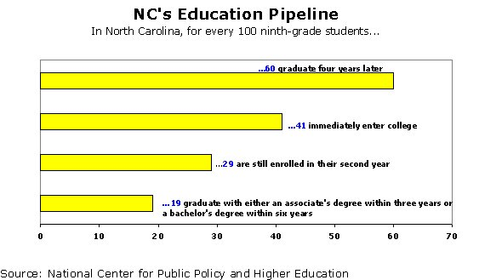

Forty-one of these 60 graduates completing high school in four years immediately enter college, compared with the national average of 40 high school graduates and New Jersey’s rate of 60 graduates. The national average attrition rate between the freshman and sophomore year is 13 students out of the original 40 freshmen not returning for their sophomore year, compared to North Carolina’s rate of 12 sophomore students of the original 41 freshmen not returning. New Jersey, the top-ranked state, loses only 16 students out of the original 60 between the freshmen and sophomore years. Finally, North Carolina has an average of 19 students who complete an associate’s degree within three years or a bachelor’s degree within six years. The national average is 18 students, and top-ranked Massachusetts has a graduation rate of 29 students out of the original 100 ninth graders.

The National Center asserts that the number of citizens that have earned a college degree form the state’s “educational capital,” which is a key to its economic development; and they conclude that “the success of the ‘educational pipeline’ varies radically from state to state. This indicates that educational policies matter.”

