Cry the Beloved Country by Alan Paton

Seminar Objectives
Given the seminar text and the seminar dialogue, students will be able to identify social issues and/or persistent problems created by South Africa’s apartheid government. Students will also be able to evaluate and reflect on the effects of apartheid on the South African economy, political, and social structures.

Pre-Seminar Activities
- Read the text (Homework)
- Review the history of apartheid in South Africa:
  - http://www-cs-students.stanford.edu/~cale/cs201/apartheid.hist.html
  - http://www.unmultimedia.org/photo/subjects/apartheid.html
- Complete apartheid chart (Figure 1—see attachment))
- View the web site for the Red Location Museum and read text from a display panel in the museum (Figure 2—see attachment)
Red Location Museum
http://www.freewebs.com/redlocationmuseum/
- Complete political map of South Africa (Figure 3—see attachment)
- Listen to audio clips of the history of apartheid from Radio Diaries
  - http://www.radiodiaries.org/mandela/index.html
- View and analyze visual images from the United Nations
  - http://www.unmultimedia.org/search/photo/
  - 1. Students should describe what they see in the images.
  - 2. Students should describe the messages in the images.
  - 3. Students should make inferences about the images—what can they infer about South African democracy using the images?
    - Using the texts in the assignments above, students will reinterpret those texts by creating found poems. Each student will write one found poem. For more information on found poetry, see http://www.readwritethink.org/lessons/lesson_view.asp?id=33

Seminar Guidelines
- Prepare
- Listen
- Speak
- Think
- Reflect

Seminar Questions

Opening questions
- Round robin: Ask each student to select and read a phrase from the text that comments on the social issues created by apartheid.
- Ask a few students to discuss the quote s/he selected and explain what the quote means.
Core questions (require specific quotes or sections of the text when answering)

- How do the geographic differences in the book affect people’s social, political, and/or economic lives?
- How do people’s perspectives of apartheid differ?
  - Follow-up—how do people struggle with contradictory opinions or feelings about apartheid?
- How do the different characters engage in politics?
  - Follow-up—How is the political process described in the novel?
  - Follow-up—What are some of the problems with the political process depicted in the novel?
- How is the word “cry” used throughout the text?
  - Follow-up—Why is the nation, in a literal and metaphorical sense, crying?
- How does the novel describe power?
  - Follow-up—How is power related to history and to language (in the text)?

Closing questions
- What issues does South Africa face now?
- Why is the educational system important in the change process?
- How is South Africa’s democracy similar to and different from United States’ democracy?

Post Seminar Activities
- Students will orally reflect on their seminar participation.
- Students will write a paragraph which answers question number 10 from the seminar.
- Students will create a political cartoon which depicts at least three challenges to the success of South African democracy.

Figure 1.

Government Law | Year Enacted | Effect
Franchise and Ballot Act | 1892 | Limited the vote of Black South Africans with monetary and educational provisions.
Natal Legislative Assembly Bill | 1894 | Prevented Indians from voting.
General Pass Regulations Bill | 1905 | Prevented all Black South Africans from voting.
Asiatic Registration Act | 1906 | Required Indians to carry passes.
South Africa Act | 1910 | Gave whites control over all other racial groups.
Natives Land Act | 1913 | Blacks could only own 7% of the land. Most Blacks could not own land.
Natives in Urban Areas Bill | 1918 | Forced Blacks to relocate.
Urban Areas Act | 1923 | Created residential segregation.
Colour Bar Act | 1926 | Restricted Blacks from practicing skilled trades.
The Native Administration Act | 1927 | Gave whites control over all South African affairs and, in effect, took control away from Black South African chiefs.
Native Land and Trust Act | 1936 | Strengthened the 1913 Land Act
Representation of Natives Act | 1936 | Erased all Black South Africans from the rolls in the Cape region.
Prohibition of Mixed Marriages Act (No. 55) | 1949 | Marriages between whites and other races is illegal.
Reservation of Separate Amenities Act | 1953 | Mandated separate facilities (bathrooms, drinking fountains, etc.) for whites and blacks and they need not be of equal quality.
Bantu Education Act | 1953 | Education of Blacks is assigned to the Native Affairs Department which sought to limit educational training of Blacks.
Industrial Conciliation Act (No. 28) | 1956 | Allowed the government to reclassify jobs as “whites only” and to increase the pay.
Extension of University Education Act (No. 45) | 1959 | Blacks could not attend white institutions.
*Compiled from South African History (n.d.) and South African Country Studies (n.d)
Figure 2. Red Location Museum Statement
Red Location Museum seeks to remember the past in many ways. It plans to depict the notion of memory, portraying both the horrors of institutionalized racism and the Heroic efforts of the anti-apartheid movement. The museum seeks to serve as a stimuli for upgrading the destitute living conditions in the Red Location shack settlement, while celebrating those who fought to end apartheid. It is therefore designed not only as a tourist attraction for foreign visitors, but also as an integral part of the surrounding community, regarding Education, Arts, & Cultural activities and also a space for Heritage Practioners in the metro. The museum seeks to portray an overall feeling of awkwardness, ambiguity, and complexity through its vibrant exhibitions.

Figure 3. South Africa Political Maps
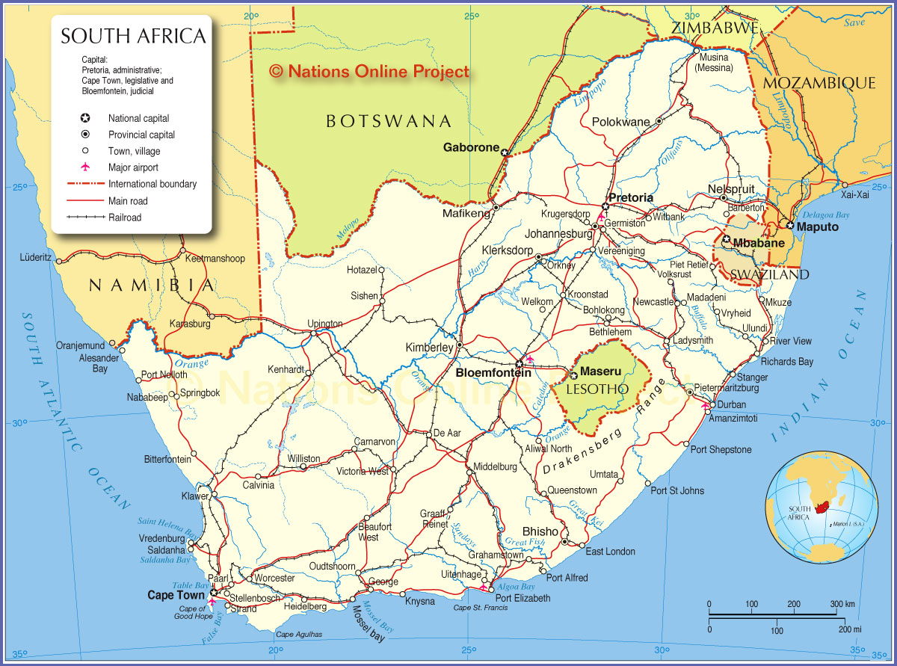
Source: http://www.nationsonline.org/oneworld/map/south_africa_map.htm
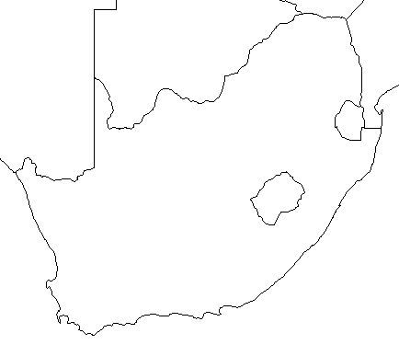
Source: http://geography.about.com/library/blank/blxsouthafrica.htm

