This mini unit will cover 2 ninety minute class periods

NCSS Goals

Civics and Economics
Goal 1.08: Compare the American system of government to other forms of government.

English 1
Goal 1: The learner will express reflections and reactions to print and non-print text and personal experiences.

Day 1

Instructional Objectives
Using visual images, historical facts, a museum exhibit, and audio clips, students will be able to identify persistent problems facing South Africa as it implements democracy. Students will compare and contrast the experiences of White and Black South Africans.

Materials Needed
Computer & Projection Screen
8 ½ x 11 white paper
Colored pencils, markers, crayons
Maps

Focus (15 minutes)
Students will write a journal response that compares and contrasts the ideals of democracy with the reality of democracy in the United States. How have your personal experiences shaped your understanding of democracy? (10 minutes)

Ask 3-4 students to share responses. (5 minutes)

Direct Instruction (15 minutes)
Review the historical context of apartheid and the democratic election of 1994. Use notes from http://www-cs-students.stanford.edu/~cale/cs201/apartheid.hist.html (pre-seminar activity)

During the lecture, have students refer to and/or label their political maps of South Africa (pre-seminar activity)

Play at least one audio clip from http://www.radiodiaries.org/mandela/index.html (pre-seminar activity)

Guided Practice (30 minutes)
Students will use photos from the U.N. exhibit on apartheid to identify and analyze the experiences of White and Black people during apartheid. The photos are located at http://www.unmultimedia.org/photo/subjects/apartheid.html.
Select 5-7 photos for students to analyze. Students will write 2 descriptive words for each photo. Students will then create found poems using all of the texts which have been discussed in class—audio clip, apartheid documents, UN photos (pre-seminar activity—30 minutes)

Independent Practice (20 minutes)
Distribute the apartheid chart and the text from the Red Location Museum exhibit (pre-seminar activities). Ask students to create a concept map that displays the effects of apartheid. Students should identify tangible and intangible effects. (Sample chart below with possible answers)

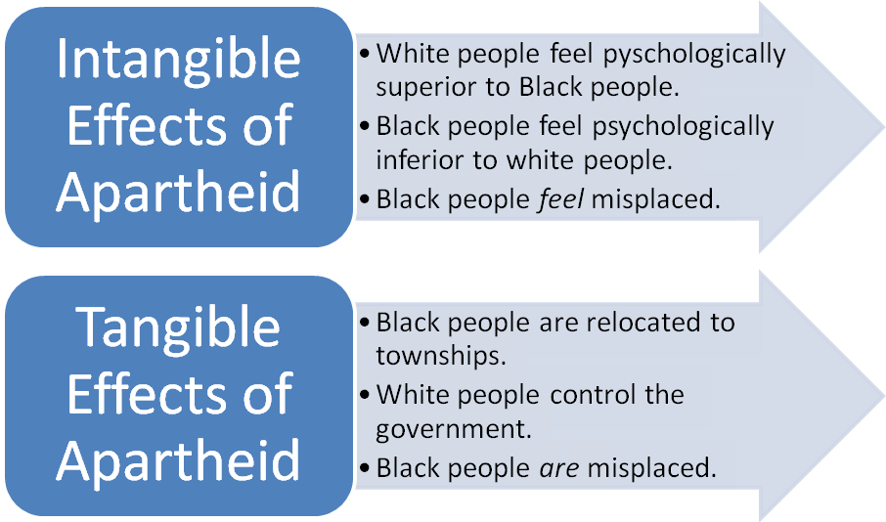

Closure/Review (10 minutes)
Extended journal response—ask students to extend their journal response from the beginning of class. Students should respond to the question: How would you compare South Africa’s struggles in implementing democracy with our own (in the United States)? How do your personal experiences shape your optimism or pessimism about South African democracy?

***Remind students that tomorrow is seminar day and they need to come to class having read the text.

Day 2

Instructional Objectives
After participating in a Paideia seminar using Cry the Beloved Country by Alan Patton, students will be able to evaluate and reflect upon the success of and challenges facing South Africa’s democracy.

Materials Needed
Seminar text
Flip chart paper and markers

Focus (15 minutes)
Review key points from yesterday’s lesson. Ask students to share portions of their extended journal responses from the end of the last class. Review guidelines for Paideia seminar participation and have students write down at least two personal goals for the seminar.

Seminar (30 minutes)
Refer to the seminar text and seminar questions.

Independent Practice (30 minutes)
Students should complete their post seminar activities
- Students will write a paragraph which answers question number 10 from the seminar.
- Students will create a political cartoon which depicts at least three challenges to the success of South African democracy. Students will juxtapose their found poems with their political cartoons.
- While students work independently, play South African music (Use The Winds of Change or a comparable one)

Closure (15 minutes)
“Rotating media exhibit”—have students pass their political cartoons and found poems around the room. Every student should see all of the images. Each student should keep a list of the challenges depicted in entire exhibit. If time permits, have students create an abbreviated master list of these challenges and post this list in the room.

