Please take a few minutes and read through this information, provided to help guide you through course selection.
To find classes for a specific term, please search the schedule of classes by following these instructions:
Go to http://isis.uark.edu/ Enter your login information (user name and password; same as for your email).
If you haven’t set up an email account yet, get your UA ID (ex: 012345678) and go to https://www2.uark.edu/web-apps/comp/techserv/account/passweb/NewUser to set this up. You will type in your UA ID, then your birth date, and click “yes” on the 3 questions. Then click next and follow the remaining steps. When you are finished, your UA email address (ex: lmoix@uark.edu) should pop up on the screen. Let me know if you need any help.
After you’ve entered the ISIS system, Find the Self Service tab in the middle of the page and click on Student Center.
When this opens, you should see your personalized student center. You will not be able to add classes at this point, but you will be able to search the classes being offered by clicking in the upper right hand corner on “Search for Classes”.
Next, check the term you wish to search (Spring, Fall, or Summer) and press go.
Enter the 4 letter abbreviation for the subject area (example: ENGL for English or MGMT for Management). If you do not know the 4 letter abbreviation, click the green “select subject” box and look for the subject name (in alphabetical order) and you can see the correct 4 letter abbreviation for your subject in the list.
Under the field Course Career select "undergraduate" from the drop down menu. Uncheck the box next to “show open classes only” if you’d like to see ALL offerings for the term, even those courses that are already full. If you’d like to view only courses that are still offered, leave the box checked.
Next click the green “search” box. This should bring up a list of the courses for the term & subject you are searching.
If you are looking at ALL the courses: if you see a green circle icon beside the status, then there are still spots available for students. If you see a blue square beside the status, then that course section is closed for enrollment. If you find a class that is closed but meets requirements that you have at your home University, you may note it on your sheet and I can ask to get you placed into the class—but, please know, I cannot guarantee space in closed courses.
Please check your course information carefully (including any assumed knowledge or “pre-requisites”: for example, if you were hoping to take Chemistry II, you would need to have completed Chemistry I at home).
Further information regarding course descriptions and timetables is available at http://catalogofstudies.uark.edu/. Please keep in mind that not all of the courses in the catalog are offered every semester.
If you have any problems using this system, please let me know at lmoix@uark.edu.
Once you’ve taken a look and picked out some courses you’d like to take while here, please list your top 8 courses on the Course Preference Sheet (found at the end of this document).
You’ll see that I’ve filled out one as an example to show you how. After looking up an English course (ENGL), I saw this below:
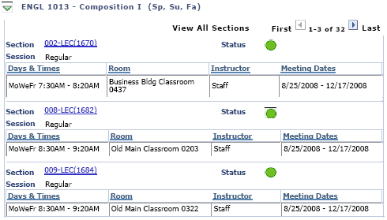

Under the red arrow, you’ll see that there are actually 32 sections of this class (it’s pretty popular) and you can scroll through to find one that is open (green circle) and at a time that doesn’t conflict with your other class choices.
You’ll find the ISIS Class Number at the top of each entry by Section. In this case: 002-LEC (1670): don’t worry about any numbers but the one in the parentheses ().
If the instructor is Staff, as it is here, that just means that they will assign a professor at a later date.
Exchange Student Registration Course Preference Sheet Fall 2012

Student First and Last Name:
9 digit UA Student ID #:______________

 | ISIS Class  Number | Subject Catalog  Number | Class Name* | Instructor | Time Offered*
Example | 1670 | ENGL | Composition I | Staff | MWF 7:30am-8:20am
1st Class Choice

2nd Class Choice

3rd Class Choice

4th Class Choice

5th Class Choice

6th Class
Choice

7th Class
Choice

8th Class
Choice

*If the class time you’ve chosen is not available, we will try to place you in the same class at a different time slot*

Return by June 22nd to:
Laura Moix
Office of Study Abroad & International Exchange
lmoix@uark.edu or fax at (001)479-575-7402

