Teacher assessment is the latest passion for fixing public education.
It will flop, as did all past, and as will all future education reforms, innovations, and transformations that rest on inadequate
(1) scope of focus (teachers, or laws, or core standards, or ed schools, or diversity);
(2) conceptualization of the phenomenon (the levels and organizations of school systems, the interconnections among these, the activities of teachers); the conceptualization and operationalization of variables;
(3) objectives (exactly what to change and how you will know whether and how much change occurred); (4) procedures (how teachers are supposed to teach, how schools are supposed to run, how teachers will be prepared and assisted);
(5) implementation (grandiose illusions, pseudo-democracy, too little too late), and research and development (no careful sequencing)

Past efforts that flopped
Follow through
ABC Accountabilit
Constructivism
NCLB
Reading First
Louisiana
Inclusion/justice: diversity, multiculturalism
Kansas City http://www.governing.com/blogs/bfc/kansas-city-desegregation-school-reform-accountability-performance.html
Why the teacher accountability movement will fail.
Because you can hardly hold teachers accountable, or improve teacher proficiency, when,
(1) Teachers were never told in ed school what they needed to know;
(2) Teachers were never taught what they needed to know;
(3) Schools do not provide much professional development in the stuff teachers weren't taught in the first place; they are taught tertiary stuff relevant to the latest fad "innovations" designed to close the achievement gap and make everyone a life-long learner and a global citizen;
(4) Districts don't know what teachers need to know;
(5) State boards of ed, legislatures, and departments of public instruction have no clue, either.
(6) Ed school can continue as usual.
(7) Public education has no stock of knowledge shared by all levels and organizations. This is because: (1) many persons in education believe that research cannot be trusted; (2) there are huge conflicts between so-called pedagogies (most of which are mere delusion and piffle); (3) the most tested and effective pedagogies (DI, explicit instruction in general) are heresy given the hegemony of so-called progressive (left-leaning, new age, anti-hierarchy, anti-rules, anti-Truth, pseudo-democratic, radical feminist, anti-colonial, anti-capitalist) “best practices.”; (3) any effort to rationalize education (to have a solid foundation of principles and methods) is demonized and trivialized with clever one-liners such as “One size doesn’t fit all”; (So, let’s do away with pants?); “Don’t be a sage on the stage. Be a guide on the side” (In other words, you don’t really instruct; children construct---except when they don’t).
(8) Most ed schools have no inventory of skills and associated objectives that would make them accountable to students and to the public.
(9) When ed schools do have anything like an inventory of skills and associated objectives, the sample has little to do with the design of curriculum and instruction and the organization and operation of classrooms, but mostly to do with faddish flap and doodle (political indoctrination) about global warming, eco disaster, global citizenship, global education, diversity, and social justice.
(10) Any identified skills and objectives that are relevant to curriculum, instruction and class organization at state, district, ed school, and local levels are vague, equivocal, subjective, and grandiose (“all students,” “life-long learners”).
(11) Most “educators” who are in a position to make a serious inventory and objectives, are too ignorant to do so. Their blather is the best they can do.
(12) Even if they were smart enough, they would not, because then they (schools, boards, ed schools, districts, dpi’s) would be accountable. “Hey, how come your (graduates, teachers, principals) can’t define abstract concepts and have no idea how to teach them?” So, such a skill is not likely ever to BE on an inventory.
In sum, education is not a profession. It is at best a pseudo-profession. It has the trappings---mission statements, entry requirements, entry examinations, professional development, external certification---but not the substance.
There can be no serious change for the better in public education as long as public education is described by points 1-12
Given the above, what is needed?
Design principles are reform---transformation.

DISCOURSES OF NICCOLO MACHIAVELLI
ON THE FIRST TEN (BOOKS) OF TITUS LIVIUS
TO ZANOBI BUONDELMONTI AND COSIMO RUCELLAI

1517
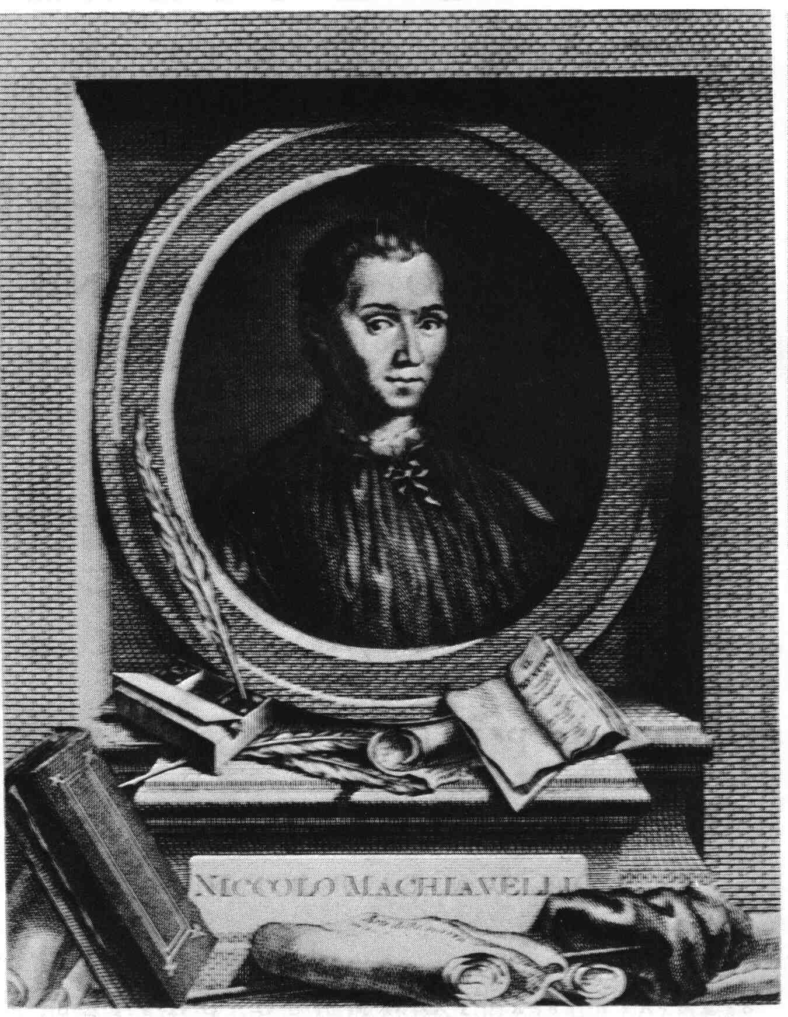

Kinds of governments

For to some, at the beginning or very soon after, their laws were given to them by one (man) and all at one time, as those which were given to the Spartans by Lycurgus: Some have received them by chance, and at several times, according to events, as Rome did. So that a Republic can be called fortunate which by chance has a man so prudent, who gives her laws so ordered that without having need of correcting them, she can live securely under them. And it is seen that Sparta observed hers (laws) for more than eight hundred years without changing them and without any dangerous disturbance: and on the contrary that City has some degree of unhappiness which (not having fallen to a prudent lawmaker) is compelled to reorganize her laws by herself. And she also is more unhappy which has diverged more from her institutions; and that (Republic) is even further from them whose laws lead her away from perfect and true ends entirely outside of the right path; for to those who are in that condition it is almost impossible that by some incident they be set aright. Those others which do not have a perfect constitution, but had made a good beginning, are capable of becoming better, and can become perfect through the occurrence of events. It is very true, however, that they have never been reformed without danger, for the greater number of men never agree to a new law which contemplates a new order for the City, unless the necessity that needs be accomplished is shown to them: and as this necessity cannot arise without some peril, it is an easy thing for the Republic to be ruined before it can be brought to a more perfect constitution. The Republic of Florence gives a proof of this, which because of the incident of Arezzo in (the year) one thousand five hundred and two (1502) was reorganized, (and) it was disorganized by that of Prato in (the year) one thousand five hundred and twelve (1512)….

Good and Bad Sides to Each Form
Wanting therefore to discourse on what were the institutions of the City of Rome and what events brought her to her perfection, I say, that some who have written of Republics say there are (one of) three States (governments) in them called by them Principality (Monarchy), of the Best (Aristocracy), and Popular (Democracy), and that those men who institute (laws) in a City ought to turn to one of these, according as it seems fit to them. Some others (and wiser according to the opinion of many) believe there are six kinds of Governments, of which those are very bad, and those are good in themselves, but may be so easily corrupted that they also become pernicious. Those that are good are three mentioned above: those that are bad, are three others which derive from those (first three), and each is so similar to them that they easily jump from one to the other, for the Principality easily becomes a tyranny, autocracy easily become State of the Few (oligarchies), and the Popular (Democracy) without difficulty is converted into a licentious one (anarchy). So much so that an organizer of a Republic institutes one of those three States (governments) in a City, he institutes it for only a short time, because there is no remedy which can prevent them from degenerating into their opposite kind, because of the resemblance that virtu and vice have in this instance….

Good Forms Do Not Last Long. Egoism and Anomie.
And because all States in the beginning receive some reverence, this Popular State maintained itself for a short time, but not for long, especially when that generation that had organized it was extinguished, for they quickly came to that license where neither private men or public men were feared: this was such that every one living in his own way, a thousand injuries were inflicted every day: so that constrained by necessity either through the suggestion of some good man, or to escape from such license, they once again turn to a Principality; and from this step by step they return to that license both in the manner and for the causes mentioned (previously)….

The Wise Prince Fosters Elements of All Three Forms
I say therefore that all the (previously) mentioned forms are inferior because of the brevity of the existence of those three that are good, and of the malignity of those three that are bad. So that those who make laws prudently having recognized the defects of each, (and) avoiding every one of these forms by itself alone, they selected one (form) that should partake of all, they judging it to be more firm and stable, because when there is in the same City (government) a Principality, an Aristocracy, and a Popular Government (Democracy), one watches the other.^{[1]…}

Contrasting Examples of Sparta and Athens
Among those who have merited more praise for having similar constitutions is Lycurgus, who so established his laws in Sparta, that in giving parts to the King, the Aristocracy, and the People, made a state that endured more than eight hundred years, with great praise to himself and tranquillity to that City. The contrary happened to Solon who established the laws in Athens, (and) who by establishing only the Popular (Democratic) state, he gave it such a brief existence that before he died he saw arise the tyranny of Pisistratus:

….As all those have shown who have discussed civil institutions, and as every history is full of examples, it is necessary to whoever arranges to found a Republic and establish laws in it, to presuppose that all men are bad and that they will use their malignity of mind every time they have the opportunity…

…men never act well except through necessity: but where choice abounds and where license may be used, everything is quickly filled with confusion and disorder. It is said therefore that Hunger and Poverty make men industrious, and Laws make them good. And where something by itself works well without law, the law is not necessary: but when that good custom is lacking, the law immediately becomes necessary….

A New Political Actor. The Tribunes of the People (Plebs)
…And therefore after many confusions, tumults, and dangers of troubles, which arose between the Plebs and the Nobility, they came for the security of the Plebs to the creation of the Tribunes, and they were given so much preeminence and so much reputation, that they then should always be able to be in the middle between the Plebs and the Senate, and obviate the insolence of the Nobles. [Persons who speak only for the students and who evaluate practices in that light.]

…One ought therefore to be more sparing in blaming the Roman government, and to consider that so many good effects which came from that Republic, were not caused except for the best of reasons: And if the tumults were the cause of creation of Tribunes, they merit the highest praise, for in addition to giving the people a part in administration, they were established for guarding Roman liberty, as will be shown in the next chapter.
I believe then that to create a Republic which should endure a long time, the better way would be to organize internally like Sparta, or like Venice locate it in a strong place, and of such power that no one should believe he could quickly oppress her: and on the other hand, it should not be so powerful that she should be formidable to her neighbors, and thus she could enjoy its state (independence) for a long time. … it is necessary in organizing a Republic to think of the more honorable side, and organize her in a way that if necessity should induce her to expand, she may be able to preserve that which she should have acquired.
But this must be assumed, as a general rule, that it never or rarely occurs that some Republic or Kingdom is well organized from the beginning, or its institutions entirely reformed a new, unless it is arranged by one (individual only): rather it is necessary that the only one who carries it out should be he who on whose mind such an organization depends. A prudent Organizer of a Republic, therefore, who has in mind to want to promote, not himself, but the common good, and not his own succession but his (common) country, ought to endeavor to have the authority alone: and a wise planner will never reprimand anyone for any extraordinary activity that he should employ either in the establishment of a Kingdom or in constituting a Republic. … He ought, however, to be so prudent and wise that the authority which he has assumed, he will not leave to his heirs (or) any other: for men being more prone to evil than to good, his successor could employ for reasons of ambition that which should be employed for virtuous reasons by him. In addition to this, even if one is adept at organizing, the thing organized will not endure long if its (administration) remains only on the shoulders of one individual, but it is good when it remains in the care of many, and thus there will be many to sustain it. As the organization of anything cannot be made by many because of the diverse opinions that exist among them, yet having once understood this, they will not agree to forego it.
And truly there never was any extraordinary institutor of laws among a people who did not have recourse to God, because otherwise he would not have been accepted; for they (these laws) are very well known by prudent men, but which by themselves do not contain evident reasons capable of persuading others….Considering all this I conclude therefore, that the Religion introduced by Numa was among the chief reasons for the felicity of that City, for it caused good ordinances, good ordinances make good fortune, and from good fortune there arises the happy successes of the enterprises. And as the observance of divine institutions is the cause of the greatness of Republics, so the contempt of it is the cause of their ruin, for where the fear of God is lacking it will happen that that kingdom will be ruined or that it will be sustained through fear of a Prince, which may supply the want of Religion. And because Princes are short lived, it will happen that that Kingdom will easily fall as he (Prince) fails in virtu. Whence it results that Kingdoms which depend solely on the virtu of one man, are not durable for long, because that virtu fails with the life of that man, and it rarely happens that it is renewed in (his) successor…

The welfare of a Republic or a Kingdom, therefore, is not in having a Prince who governs prudently while he lives, but one who organizes it in a way that, if he should die, it will still maintain itself. And although crude men are more easily persuaded by new ordinances and opinions, yet it is not impossible because of this to persuade civilized men, (and) who presume themselves not to be crude.
But as to the desire of the people to regain their liberty, the Prince, not being able to satisfy it, ought to examine what are the reasons that make them desire to be free, and he will find that a small part of them desire to be free in order to command, but all the others, who are an infinite number, desire liberty also as to live in security. … The others, to whom it is enough to live in security, are easily satisfied by creating institutions and laws which, together with his power, gives realization to the general security of the people. And when a Prince does this, and the people see that no one breaks such laws by accident, they will begin in a very short time to live in security and contentment.
but where corruption exists, well ordered laws are of no benefit, unless they are administered by one who, with extreme strength, will make them be observed until
From all the things written above, arises the difficulty or impossibility of maintaining a Republic in a City that has become corrupted, or to establish it there anew. And even if it should have to be created or maintained, it would be necessary to reduce it more to a Royal State (Monarchy) than to a Popular State (Republic), so that those men who because of their insolence cannot be controlled by laws, should be restrained by a Power almost Regal. And to want to make them become good by other means would be either a most cruel enterprise or entirely impossible…
He who desires or wants to reform the State (Government) of a City, and wishes that it may be accepted and capable of maintaining itself to everyone's satisfaction, it is necessary for him at least to retain the shadow of ancient forms, so that it does not appear to the people that the institutions have been changed, even though in fact the new institutions should be entirely different from the past ones: for the general mass of men are satisfied with appearances, as if it exists, and many times are moved by the things which appear to be rather than by the things that are….And this ought to be observed by all those who want to abolish an ancient (system of) living in a City and bring it to a new and more liberal (system of) living. For as new things disturb the minds of men, you ought to endeavor that these changes retain as much as possible of the ancient (forms); and if the magistrates change both in number and in authority and in duration (of term) from the ancients, the names at least ought to be retained. And this ((as I have said)) ought to be preserved by whoever wants to organize an absolute power into a Republic or a Kingdom; but he who wants to establish an absolute power, which by authors is called a Tyranny, ought to change everything, as will be mentioned in the following chapter.

Here it is seen how harmful it is to a Republic or to a Prince to keep the minds of their subjects in a state of fear by continuing penalties and suspended offenses. And without doubt no more pernicious order can be held; for men who begin to be apprehensive of having done a capital evil, will secure themselves from perils in every way, and become more audacious and have less regard in attempting new things. It is necessary, therefore, either never to offend any one or to make the offense at a stroke, and afterwards to reassure men and give them cause to quiet and firm the spirit.

Permit No Obstacles to Implementation
…(T)here ought never to be established in a City the ability of a few to interrupt any of its decisions which are ordinarily necessary in maintaining the Republic. For instance, if you give authority to a Council to make a distribution of honors and offices, or to a Magistracy the administration of a business, it is proper either to impose on them the necessity that they must do it in any case, or to arrange that if they did not want to do it themselves, that another can and ought to do it: otherwise this constitution would be defective and dangerous…
that there is no sounder or more necessary remedy to restrain an excited multitude than the presence of a man who by his presence appears and is revered.

Identify Main activities of teachers
1. Designing and delivering instruction from textbooks and supplements http://people.uncw.edu/kozloffm/teaching from textbooksblank.doc
2. Assessing and improving programs Form for Assessing and Improving Curriculum Materials and Instruction
3. Designing curriculum and instruction in elementary school http://people/uncw.edu/kozloffm/Designing Curriculum and Instruction in Elementary School.doc
4. Designing and running the class as a social organization.

Do a knowledge analysis. Identify steps by which each is accomplished and background (elementary) knowledge that is needed.

Develop inventories of above. Full descriptions of the activity/routines and each item of background knowledge; how to do it; how to assess it; where to learn it.

Develop resources for initial teaching and professional development, and for assessment and assistance: protocol for use of documents, video, workshops, mentoring, teams, interviews, supervision, observation
TX pdp
Assessment form
TX walk through
TX Report
TX Reflect
Research and Development.

http://people.uncw.edu/kozloffm/Assessing and Improving Curriculum Materials blank.doc
http://people.uncw.edu/kozloffm/teaching from textbooksblank.doc
http://people.uncw.edu/kozloffm/Designing Curriculum and Instruction in Elementary School.doc
A lot of the resources for teaching the routines and the elements are here...
http://people.uncw.edu/kozloffm/EDN301.doc
You guys have a lot more!
The position paper (far from done) is here...
http://people.uncw.edu/kozloffm/Teaching Proficiency Inventory.doc
The assessments of state teaching proficiency assessments are here. Scroll down.
http://people.uncw.edu/kozloffm/EDN%20523.doc

