Day 2
Thursday, August 28, 2008
12:33 PM
Hawking UM
Universe _ stars, planets.galaxies....
-far away
speed of light. 186,000 mils Alpha Centavi C I 4 light years
Earth's Evolution
Flat?
Evidence - stars motion
-ship on seas
Our Position in the Universe
geocentric + heliocentric
scientific theory
good Theory _ Hawking
Daccurately describe a
large class of observations
•_ model to be as simple as possible
YIdefinite predictions
Karl Popper. good theory
predictions can be proved or
falsified by making observations
Need Community to verify
Is there one theory of the universe?
Forces of universe Q Electrical t Magnetic Maxwell 1860
EM Waves
Dweak Force beta decay
Qstrong Force quarks
Standard Model ~ glashow, Salami Weinberg
Dgravitation-general Relativity
.

Day 3
Thursday, September 04, 2008
2:09 PM
What did you learn from the videos?

Who were the important people?

From http://www-groups.dcs.st-and.ac.uk/~history/BiogIndex.html



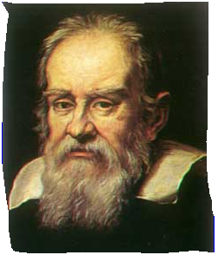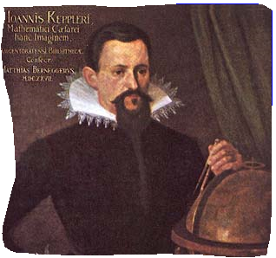

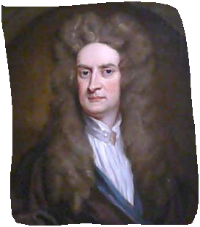

Electricity and Magnetism

Let there be light!

