Aptitude Treatment Interaction & Cognitive Style
(from: http://home.okstate.edu/homepages.nsf/toc/EPSY5463C12)
Table of Contents
Aptitude Treatment Interaction
Arousal as an Individual Difference
Cognitive Style
Examples of Cognitive Styles
A Multiplicity of Styles
Synthesizing the Style Variables
Developmental Implications: McCarthy's System
Other Approaches to Cognitive Style
Style, Ability & Educational Structure
Summary
Discussion Questions
Bibliography
Aptitude Treatment Interaction and Cognitive Styles
In this chapter we will examine the idea of an aptitude-treatment-interaction and also some of the variables subsumed under aptitude, called cognitive styles, along which people are distributed. Basically, the idea heretofore has been that, with a few exceptions, each learning theory has purported to deal basically in the same way with every learner. There has been no systematic attempt to look at individual differences among learners and prescribe different ways to deal with them or different mechanisms by which they might learn. This chapter tries briefly to rectify this problem. We can, of course, deal with only some segments of the dimension known as individual differences. Because differences in ability are adequately dealt with in special education and because differences in personality are dealt with in counseling, we have chosen to ignore the impact of ability and personality on the learning process and to focus on other stylistic variables which are less well described in our literature.
Let us first look at the idea of how we might deal with differences between learners in a very simple sense, the aptitude-treatment-interaction. Here the basic idea is that if there are two different aptitudes or there are at least two levels, high and low, of an aptitude, then it may be that there are at least two most appropriate ways to learn for those with different levels of aptitude. These may be spelled out in differential treatments.
Aptitude Treatment Interaction
Cronbach and Snow (1977) popularized the idea of the aptitude-treatment-interaction (ATI). They were not the first to argue that there are specific, narrow abilities that improve the learning of certain content in certain ways. For many years there have been multiple ability models such as Guilford's (1967) that would imply that those with high levels of a certain ability would learn better when that ability was tapped in the learning process. We saw the basis for this in the last chapter with the development, by Feuerstein, of the Instrumental Enrichment model.
Cronbach and Snow (1977) acknowledge that others had advocated a similar premise, but not with the same rigor or eye to design when they quote the results of Herbert Woodrow (1946) who developed the following generalizations:
1. "The ability to learn cannot be identified with the ability known as intelligence.
2. Individuals possess no such thing as a unitary general learning ability.
3. Improvement with practice correlates importantly with group factors, that is, relatively narrow abilities, and also with specific factors.
4. Even the group factors involved in learning are not unique to learning, but consist of abilities which can be measured by tests given but once" (p. 148-149).
So what are ATI's and how do they influence learning? Aptitude-treatment-interactions (ATI's) begin by assuming that people with different abilities learn in different ways. The assumption is not that those with less of a specific ability are just slower in that area; the assumption is that they are qualitatively and quantitatively different. This difference may be dealt with if different methods are used to support learning. This intuitively makes sense when you look at the variety of teaching techniques that are proposed by authors in educational methods, Joyce and Weil (1987). The assumption must be that if there are forty or more different teaching models (treatments), that some must be better for one class of students than another class of students (where class is used in the sense of level). The ATI then describes what happens with different groups of students who are treated differently based on their abilities. The interaction comes when the treatments are graphed on a Cartesian coordinate system graph showing acquisition on the "y" axis and treatment order on the "x" axis.
Different students learn best in different ways. This is most clearly exemplified by studies of aptitude x treatment interactions (ATI's). ATI's relate typically to the differential effect of a treatment (learning method) across two extremes of ability level. When the data is graphed, we see either ordinal or disordinal interactions across treatment or style conditions. See Figure 12. 1.
Figure 12.1 Two types of aptitude by treatment interactions, the criss-cross "disordinal" ATI and the diverging "ordinal" ATI.
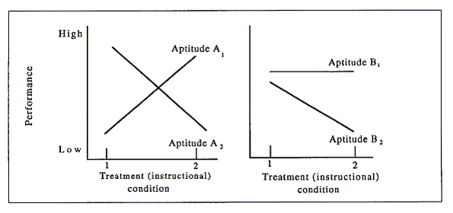
Davis (1983)
Knowledge of ATI's are useful in dealing with learners who are either weak or strong using a particular approach to learning. Davis (1983) describes three approaches to the use of ATI's to improve learning. The capitalization approach says go with the student's strengths. The compensation approach says provide a crutch if weakness is predicted, and the remediation approach in which the weakness is worked on until it is overcome.
One limitation of the ATI model is it assumes that aptitudes are traits and are relatively fixed over time, a very different approach from Feuerstein. The model is also static and only a few dimensions are summed to describe a given person.
Now that we have overviewed the ATI, let us look at it in a little more detail so that those with only a limited background in statistics and measurement can understand the theory behind it. All of the illustrations to follow in this section are from Cronbach and Snow (1977).
Typically, when we advocate differential treatment for different groups of learners, we do so because we believe that it is more effective, efficient, or less costly to do so. This is illustrated for a single group in Figure 12.2. For example, we might have a treatment, say graduate school, which could be applied to all who wanted it.
Figure 12.2 The scheme for examining predictive validity.
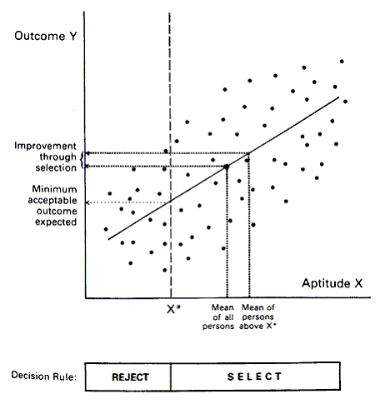
Cronbach and Snow (1977)
However, if standards were at all rigorous, success would be unlikely for many and, therefore, scarce resources would be wasted. So a criterion measure of ability, the "x" in our figure, might be applied, let's call it the Graduate Record Examination (GRE). We then could establish a cut off score, say "x*." Looking at the mean of persons above "x*" in relation to the mean of all persons taking the GRE, we can see that we save a segment of resources and probably graduate more candidates by using such a measure. This is the basis of the beginnings of the ATI. Note that we assume that the world is linear and related to a single variable for this kind of a prediction model. This may not be an appropriate assumption in all cases as we will see in the section on arousal.
Anyway, based on our single aptitude model, we see that the imposition of a cut off score will improve the capability of the overall body of learners by selecting those who are more likely to succeed. In Figure 12.3, we see the beginnings of a scheme to compare two treatment means or averages.
Figure 12.3 The scheme for comparing treatment means
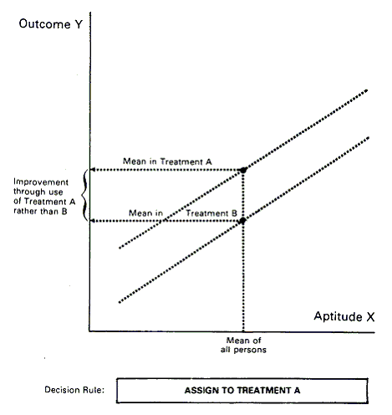
_____________________________________________________________________
Cronbach and Snow (1977)
Here the first treatment, "A," is always more productive, efficient, and so forth, throughout the range of the treatment. This means that given a choice we should always put someone into treatment "A." No matter what level of aptitude "x" a person holds, we should always put the person into "A."
Figure 12.4 shows a scenario where an aptitude treatment interaction is evident.
Figure 12.4 The scheme for examining aptitude treatment interactions
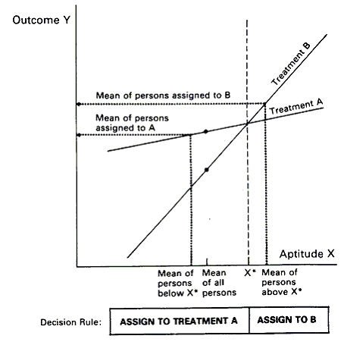
Cronbach and Snow (1977)
Here we divide the entire group at "x*." Again we compute the means for the split group, those below "x*" and those above "x*." When we look at the two treatments, it is easy to see that those below "x*" should be assigned to treatment A; the slope of the line is lower. Therefore, those toward the bottom will make greater progress than those same people would if placed in treatment B. The opposite is true for those who are above "x*." They are better off in treatment B. Those who receive A will not do as well as those who receive B, but their performance as a group will improve over that which they would have had if they had received B.
One of the problems with the ATI model is illustrated in Figure 12.5. Here we see an aptitude continuum; for example, intelligence as measured by test X.
Figure 12.5 Blocking on aptitude in ATI analysis
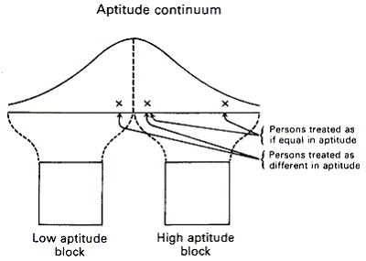
Cronbach and Snow (1977)
The scores on test X are normally distributed so the shape of the curve is like a bell with an equal number of scores on either side of the mean. If we use a median or mean split, we can create a high and low aptitude block so that people can be assigned to treatments as was done in Figure 12.5. Note, however, what happens to those who are close together in different blocks and those who are far apart in the same block. These pairs are treated as if they are different in aptitude. In some cases this may be seen as problematic, such as when placing children in a special class for the gifted or placing the child in a regular non-accelerated/non-enriched class.
When designing learning settings, those who are in charge should consider the possibilities of ATI's when various treatments are proposed. It is assumed that effectiveness and efficiency should dictate differential treatment if there are significant gains to be made in acquisition by such differential treatment. In the next section, we will look at an individual difference which we have already briefly explored which could be used as a possible basis for an ATI in the learning of some, if not all, contents.
Arousal as an Individual Difference
Sensation seeking or arousal seeking (Zuckerman, 1979) is another characteristic which is called either a personality variable or a cognitive style. People who have high sensation seeking needs are interested in risk taking, danger, and excitement. They need stimulation to raise their performance to an optimal level. Those who need stimulation would typically perform poorly in traditional learning settings because the environments are not stimulus laden. Stimulus avoiders, the opposite side of the inverted "U" curve, avoid stress, anxiety, excitement, and so forth. They typically will learn well in a stimulus-deprived environment. The stimulation-seeking factor may go a long way toward explaining the problems that some children have with learning due to distractibility. It is hypothesized that hyperactive children who are calmed by amphetamines are stimulus seekers who are chemically rebalanced (aroused) by the drug treatment that in turn improves their performance.
Figure 12.6 illustrates this stylistic variable. It should be noted that this curve is for one individual in relation to a given task.
Figure 12.6 Diagrammatic illustration of the Yerkes-Dodson law. The curve shows the theoretical relationship between level of arousal and expected quality of performance.
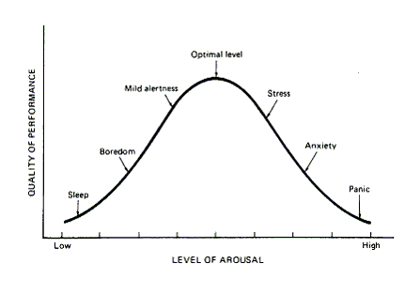
Wingfield (1979)
Other individuals might exhibit other curves; that is, the midpoint of the curve might shift either to the right or left.
In our illustration we see that when the learner is in a low arousal state the quality of performance will be low. If the level of arousal is too low, sleep may occur. Obviously, this would be detrimental to learning. If given a choice, a learner in this setting would choose to do something else which would provide more stimulation. Because of this, the learner's attention will drift if other ambient stimuli are more arousing (attractive/stimulation) than the one that is intended for the learner to attend to. This relates back to what we have seen earlier in several other models, the development of a learning set. If the under-aroused learner is interested in the learning and is told what to look for, this will increase the level of arousal, prepare the learner to learn, and improve the learning performance by moving the learner up the arousal curve.
On the other side of the curve, the student who is over-aroused feels stress and anxiety when in contact with the material to be learned. This is probably a particular problem when the student is called upon to perform in front of classmates. Such a student may be capable of performance but may fail to perform because of over-arousal. Students who are over-aroused may also freeze when taking examinations. Over-aroused students will fail to attend to cues in the learning process and will, in extreme cases, revert to primitive approaches to learning, such as memorization when appropriate cognitive structures are available.
It is clear that the arousal level of a learner is an important variable in that person's learning. Anytime that the learner attempts or is presented with a task that is not at the optimal level, his/her performance is degraded. Learners will, with some training, be able to select tasks that are at an optimal level of arousal if choices are provided. When this is done, learning will be efficient and effective; when it is not, the performance of the learner will be more or less degraded.
Students in schools who are in the tails of the arousal distribution are likely to be labeled for it. You may see those who are very low in arousal labeled hyperactive or as having attention deficit disorder. On the other end of the distribution, students who consistently narrow their view of the world and insist on maintaining and attending to only a narrow range of stimuli are typically labeled autistic or in the extreme--catatonic.
We must also be aware of the cyclical nature of information overload. As we are presented with new information, we can assimilate it as long as it does not come too fast. We need to know information in a perfect world, and we seek it. We receive massive amounts of information that puts us into overload. This in turn increases anxiety and reduces performance; that in turn reduces the amount of information that can be obtained.
Cognitive Styles
The idea that people are different in a variety of ways has just recently in the last twenty years come on to the scene in the area of learning. This means that there has not been a great deal of cumulative research conducted; therefore, there are still those who are unconvinced style variables have a place in learning theory. Others, however, have adopted cognitive styles. Marton (1988) differentiates learning into what is learned and how it is learned. The what portion deals with the hierarchical and the communicative intent aspects of what is learned. The how deals with the approach to learning as in what learning style (Holistic/atomistic) and to how the information is recorded at a deep (meaningful) or surface (rote) level. Cognitive style refers to the way a learner organizes, filters, transforms, and processes information. A person's cognitive style is determined by the way in which a person takes in the environment in which he/she is embedded. It is composed of variables related to how we think, how we feel, and how we sense (or acquire input). Each learner builds his/her own worldview, and that worldview is highly idiosyncratic. A person's cognitive style is a pattern of strategies that are used to resolve problems including learning.
Messick et al. (1964) says that cognitive styles are, "…information processing habits representing learner's typical mode of perceiving, thinking, problem solving and remembering" (cited in Keefe 1979, p. 8). Although the focus here is an information processing, we will see later that style variables are applicable to a variety of theoretical models.
McNally (1987) asserts that learners are differentially prepared to learn. From an information processing point of view, the relative preparedness of a learner for learning about a given situation is determined by the amount of input that must occur before output reliability occurs. Some styles increase preparedness in one situation and others increase preparedness in other situations. For example, impulsivity/reflectivity is thought of as a style dimension. For studying books, the reflective student who takes information in and thinks about it is likely to do well in book learning. On the other hand, the impulsive student who is always seeking new stimulation, probably due to being low in arousal, is much better than the reflective in the jungle.
Cognitive style does not encompass all of the areas of difference between learners. Some differences, as we have seen previously, are due to differences in ability. Therefore, we should differentiate between cognitive styles and cognitive abilities.
The difference between cognitive styles and cognitive abilities is that abilities deal with the content of cognition. They typically are related to the kind of information being processed, specifically by what operation and in what form. Styles, on the other hand, describe how the information is being processed.
We must also look at the differences between learning theory, as typically presented, and cognitive or learning styles. There are two aspects of learning which all who deal with learning must eventually recognize: outcomes of learning (this is where most learning theory goes) and approaches to learning (now thought of as stylistic approaches). Clear differences occur between individuals as they approach the learning task. Unless these differences are recognized and accommodated for, the practice of learning or the application of learning theory will be in some cases futile, and in many, inefficient.
At a deep level, cognitive styles control the individual's information processing system. The cognitive style controls are influenced by the affective and environmental components that the learner brings to the learning system, Keefe (1988).
There is some argument in the literature as to the term cognitive style. Some see it as the supraordinate concept; others see it as a more narrow and constrained term. This has sometimes led to confusion. For example, Keefe (1979) defines learning style as "characteristic cognitive, affective, and physiological behaviors that serve as relatively stable indicators of how learners perceive, interact with, and respond to the learning environment" (p. 4). He says that learning styles relate to the ways in which children learn and the ways they like to learn. Learning styles have cognitive, affective, and environmental components (Keefe, 1988). Affective style (Keefe, 1988) is the label for motivational processes such as attention, expectancy, and so forth that are related to the learner's typical arousal, directing and sustaining behavior. The physiological dimension deals with variables such as processing speed. Finally, the cognitive dimension deals with areas already discussed such as simultaneous and successive processing.
Others use different groupings, but conceptually they are similar. For example, cognitive styles are described habitual processes of thinking, perceiving, and sometimes behaving; Davis (1983) lists six different cognitive styles. Internal/external locus of control is sometimes characterized as a personality variable--other times as a style variable. Students who have an internal locus of control believe that they are in control of their own learning and destiny. Those with an external locus of control believe that others control them. This can cause significant differences in the ways in which learners respond to typical learning situations. This style variable is one component used in attribution theory which is described elsewhere (see Wiener, 1982). Some of the learning data related to locus of control indicates that those with internal control are likely to be high achievers (Lefcourt, 1976) and that those with learning problems are likely to be more external (Chapman & Boersma, 1979).
Just as different learners learn in different ways according to different models, both inter- and intra-individual differences will affect learning. Inter-individual differences include differences in ability, motivation, dexterity, speed, and past knowledge of the content. Intra-individual differences can also be seen in ability; an individual can be better in reading than in mathematics; motivation, you can like one area better than another; and past knowledge, you are likely to know more about the things you like than the things that you dislike. There is, as of yet, no definitive measure or definition of cognitive style. Style is a metaphor for a constellation of differences that are seen differentially in different groups by different researchers. This does not mean that they do not exist; it means that they are still in the process of being defined. In learning theory, we have, for a long period, ignored stylistic differences in the same way that we have ignored differences in ability. This is fine when one is trying to build a grand theory for how humans learn, but it is relatively unhelpful when one wants to deal with an individual learner who may or may not learn well given a particular approach to learning.
There are some indicators, however, that style variables relate to specific learning applications. Gregorc and Ward (1977) showed strong correlations between cognitive style and preferred learning style (media). Concrete/sequential learners chose ditto sheets, workbooks, CAI, etc. Those with abstract/random dispositions preferred TV, movies, or group discussion; abstract/sequential learners preferred lectures, audio tapes, and reading assignments; and concrete/randoms preferred games, simulations, and independent study.
Example of cognitive styles: here we could list many different stylistic variables. Some would be called style variables by all and others would be called abilities, at least by some. For example, Das (1988) describes simultaneous and successive processing as learning style variables. This is similar to Kaufman's K-ABC based measure of ability. Learning styles are cognitive styles applied to the way one goes about learning something; therefore, the use of simultaneous and successive processing makes sense even though others deal with them as ability variables.
Simultaneous processing describes the ability to deal globally with two or more pieces of cognitive or perceptual information. Successive processing deals with the ability to handle a series of pieces of information like links in a chain. Kauffman has used these abilities as the basis for an intelligence test. But Das (1988) calls them style variables. This goes to show that the same variable can be perceived differently by different researchers.
Another cognitive style variable with some extensive research to support it is impulsivity-reflectivity. Impulsive students tend to jump at the first response whereas reflective students think about (or reflect on) their answers. Reflective students make fewer mistakes and are probably more analytical. The reflective learner takes more time to analyze the structure of the problem and the details that are presented. Usually, this could lead to a lower error rate. Reflective students are better when the learning calls for inductive reasoning (Kagan, Pearson & Welch, 1965) or memory (Kagan, 1966). They also are better, generally, at schoolwork (Messer, 1970), most of which requires an analytic and reflective approach. A cognitive style, such as impulsivity/reflectivity, will affect the way in which competence can be used or deployed when it has developed to its full capacity, Brodzinsky (1985). Impulsive individuals, for example, perform tasks rapidly, but usually with a high error rate. Reflective individuals are slower but more accurate. This style affects learning when we wish to measure acquisition. Impulsive learners will have lower initial acquisition scores than will reflective learners. Much of the research in cognitive styles has focused on individual differences, but there are clearly task and situational differences, as well, which will positively or negatively affect learning. Conceptual tempo (impulsivity/reflectivity) yields four groupings based on a median split of latency and errors. This is shown below:
Errors
AccurateInaccurate
LatencyFastImpulsive
SlowReflective
One's position is likely to maintain position over time, according to Brodzinsky (1985).
However, as one grows older, one becomes more reflective, at least until adolescence. Reflective students, according to Brodzinsky (1985), are more likely to be more efficient in learning because they can use the rule system and knowledge base related to academic problems better than can impulsive students. When tasks are simple, impulsive children should learn more efficiently; but when tasks require analytic planful problem solving, the reflective children should perform better. It follows, therefore, that reflectives perform better on conservative tasks than do impulsives.
Another style variable is the concrete/abstract dimension. Goldstein and Blackman (1978) report this dimension. Abstract learners are capable of differentiation and integration. They are self-reliant and tolerant of ambiguity. They deal well with stress and are typically near the top of their arousal curves. They can see alternatives to problems and emotionally do not have difficulty with role taking and expressing good self-concept.
Concrete learners are at the opposite end of the continuum from abstract learners. Concrete learners tend to be poor in differentiation. They are not completely integrated. They have a dichotomous view of their surroundings and tend to rely on authority. Under low levels of stress, they are rigid; and they collapse as stress increases. Think back to the arousal curve. This implies that even apparently low stress is beyond the midpoint of the arousal curve for these individuals. Because of their intolerance for ambiguity, they are unable to delay closure long enough to generate alternative solutions to the problems. Concomitant with concrete thinking comes less of an ability to role-play and to think hypothetically. Finally, the concrete person tends to have a poorly defined self-concept.
Another cognitive style variable, the one on which the most research has been performed, is field dependence/field independence (Witkin, Moore, Goodenough, & Cox, 1977). Sometimes called global vs. analytical thinking, this variable reflects on how learners think and process information. The field dependent learner is one who processes information globally. This learner is less analytical, not attentive to detail, and sees the perceptual field as a whole. This whole resists analysis or decomposition. The field independent person, on the other hand, can easily break the field down into its component parts. He/she is, typically, not influenced by the existing structure and can make choices independent of the perceptual field. Field dependent persons are more socially oriented; therefore, they respond more to reward and punishment (Ferrell, 1971). They also need more explicit instructions when material to be learned is disorganized. They also are less able to synthesize and analyze (Frank & Davis, 1982).
Field independence/field dependence deals with the amount of psychological differentiation experienced. Differentiated systems are more complexly organized. The relationships between the system and the environment are more elaborate. Witkin and Goodenough (1981) describe the differentiation process as one of the creation of inner boundaries between the inner core of the self and the environment. Psychological activities also have boundaries and are separated from each other and the environment. Differentiation creates a hierarchical structure forming an articulated system. Field independence requires a restructuring of the perceptual or psychological field and, therefore, is a more differentiated process.
According to Witkin and Goodenough (1981), field dependent learners are more socially oriented than field independent learners. They pay more attention to social cues; they like to be with others; and they seek learning and vocational experiences that put them in contact with people. Field dependent children perform less well on formal operations tasks than do field independent children, Brodzinsky (1985). Other researchers support this. For example, children, according to Witkin and Goodenough (1981), are more field dependent than are adults. There is a general movement toward field independence across development, but there are also great individual differences. Those who develop more rapidly toward field independence also develop greater competence in cognitive restructuring. Interestingly, evidence is presented (from primitive agricultural and nomadic herding societies) which indicates that there is genetic selection of field independent subjects in primitive settings and that more are field dependent as the culture grows and becomes more modem.
Garger and Guild (1987) have summarized the characteristics of field independent and field dependent learners. These are reported in Table 12. 1. From this table, it is clear that, at least in the extremes, the two styles are very different.
Table 12. 1. Independence/Dependence Descriptions.
Learning Styles
FIELD-DEPENDENT | FIELD-INDEPENDENT
Perceives globally | Perceives analytically
Experiences in a global fashion, adheres to structures as given | Experiences in an articulate fashion, imposes structures of restrictions
Makes broad general distinctions among concepts, sees relationships | Makes specific concept distinctions, little overlap
Social orientation | Impersonal orientation
Learns material with social content best | Learns social material only as an intentional task
Attends best to material relevant to own experience | Interested in new concepts for their own sake
Requires externally defined goals and reinforcements | Has self-defined goals and reinforcements
Needs organization provided | Can self-structure situations
More affected by criticism | Less affected by criticism
Uses spectator approach for concept attainment | Uses hypothesis-testing approach to attain concepts
Teaching Styles
FIELD-DEPENDENT | FIELD-INDEPENDENT
Prefers teaching situations that allow interaction and discussion with students | Prefers impersonal teaching situations such as lectures. Emphasizes cognitive aspects of instruction.
Uses questions to check on student learning following instruction | Uses questions to introduce topics and following student answers
Uses student-centered activities | Uses a teacher-organized learning situation
Viewed by students as teaching facts | Viewed by students as encouraging to apply principles
Provides less feedback, avoids negative evaluation | Gives corrective feedback, uses negative evaluation
Strong in establishing a warm and personal learning environment | Strong in organizing and guiding student learning
How to Motivate Students
FIELD-DEPENDENT | FIELD-INDEPENDENT
Through verbal praise | Through grades
Through helping the teacher | Through competition
Through external rewards (stars, stickers, prizes) | Through choice of activities, personal goal chart
Through showing the task's value to other people | Through showing how the task is valuable to them
Through providing outlines and structure | Through freedom to design their own structure  Garger and Guild (1987)
We must remember, however, that the style variables are at either end of a bi-polar continuum and that they are normally distributed. Therefore, the relationships we saw in the section on ATI's will hold, and people in the middle of the distribution may be categorized differently when there is little real distance between them.
From Table 12.1, we can see some of the relationships to the field dependence/field independence variable which have an impact on learning. Both the responses of the student in the teaching area and in the ways they are motivated are very different for the two ends of the continuum.
A Multiplicity of Styles
During the 1970's, a number of researchers investigated a variety of cognitive/learning styles. Keefe (1979) compiled and synthesized a list of the styles that had been investigated at that point. Later, (1988) he compiled a list of forty separate styles. He categorized these styles into five groupings, some of which are detailed below.
Keefe identified physiological styles which he identified as biologically based response modes which were founded on sex differences, personal nutrition, health, and accustomed reaction to the physical environment. These include masculinity/femininity, need for mobility, sound preference, light preference, temperature preference, and time of day preference or circadian rhythm.
Keefe also identified the following as attentional styles: conceptual level (impulsivity/reflectivity), level of curiosity, persistence or perseverance, level of anxiety, and frustration tolerance.
Keefe (1979) lists receptive styles, a subset of cognitive styles as
1. Perceptual modality preferences (visual, auditory, kinesthetic)
2. Field independence/dependence
3. Scanning -- how attention is deployed
4. Constricted vs. flexible control learner response to distraction and distortion
5. Tolerance for incongruity
6. Strong vs. weak automatization how does one perform repetitive tasks
7. Conceptual vs. perceptual
Keefe (1979) lists the following as expectancy and incentive styles:
1) Locus of control
2) Achievement motivation
3) Self-actualization
4) Imitation
5) Risk taking vs. cautiousness
6) Competition vs. cooperation
7) Level of aspiration
8) Reaction to reinforcement
9) Social motivation
10) Personal interests
Keefe (1979) lists concept formation and retention styles, another subset of cognitive styles, as:
1) Conceptual tempo - speed and adequacy of processing. The dimension is typically measured in impulsivity/reflectivity.
2) Conceptualizing styles -- deals with the creation of structures in conceptualization ranging from undergeneralization to overgeneralization.
3) Breadth of categorizing -- broad or narrow conceptual categories.
4) Cognitive complexity versus simplicity.
5) Leveling vs. sharpening
Levelers and sharpeners are two ends of a visual sensitivity continuum. Sharpeners tend to notice contrasts, and revelers are most likely to notice similarities or things that look alike. Sharpeners find it easy to shift from one conceptual framework to another; revelers do not. Levelers tend to be more field dependent and global.
In 1988 Keefe collapsed his large list and developed a shorter composite list. This list, which is now the basis for a style instrument, is shown in Table 12.2.
Table 12.2 Twenty Elements of Style
1. Perceptual modality strengths/preferences
2. Field independence/dependence (analytic vs non-analytic)
3. Simultaneous-successive processing (information processing tendencies)
4. Focusing-scanning (attention deployment)
5. Inductive-deductive (conceptualizing styles)
6. Reflexive-impulsive (conceptual tempo)
7. Narrow-broad categorizing (equivalence range)
8. Simple-complex (cognitive complexity)
9. Sharpening-leveling (memory styles)
10. Active-reflective orientation (introversion-extraversion)
11. Thinking judgement-feeling judgement (decision-making values)
12. Social motivation (socio-cultural determinants)
13. Anxiety (arousal and activation)
14. Need for structure (conceptual level)
15. Achievement motivation (need for achievement)
16. Risk taking-cautiousness (tolerance for ambiguity)
17. Persistence
18. Time of day preferences (circadian rhythms)
19. Environmental elements (sound, light, temperature, formal-informal)
20. Need for mobility
___________________________________________________
Keefe (1988)
Many who have done research in the styles area have thought that there were too many styles and that some of them could be collapsed.
Synthesizing the Style Variable
McCarthy (1980) attempted to synthesize a number of style variables that centered on two dimensions--those of concrete experience/abstract conceptualization and active experimentation/reflective observation. A number of researchers namely Kolb, Lotas, Jung, Fischer(s), Merrill, Gregoric, Wetzig, Herrmann, and McCarthy had all developed instrumentation or theoretical systems along these dimensions. McCarthy (1980) defines four types of learners and says that each has a different preferred learning mode. Innovative learners like to learn by sensing, feeling, and watching. Analytic learners like to learn by watching and thinking. Common sense learners like to learn by thinking and doing; and finally, dynamic learners like to learn by doing, sensing, and feeling.
McCarthy (1980) has described the learners in each of the four dimensions as follows: the innovative learners (between concrete experience and reflective observation) are those who are meaning seekers. They try to be personally involved. Typically, they would like to learn by listening and sharing their ideas with others. They are absorbed in and by reality. They deal with tangible things in a concrete way; but when they think about them, they do so in a reflective manner. They are people and culture oriented. They diverge and create. They believe in their own experience and can view new situations from a variety of perspectives. They respect and follow those whom they respect. Typically, they function best through social interaction. The innovators are imaginative and idea people. They are subject to peer influence and tend to be emotional. They like to create their own structure by playing with ideas.
The analytic learner (between reflective observation and abstract conceptualization) is a fact seeker. This learner learns from experts and from thinking about ideas. They prefer abstract to concrete information, and they process it reflectively. There is less interest in people for the analytic learner and more interest in ideas and concepts. They are data driven and critical of the information they collect. They are thorough and industrious. They function well in traditional learning settings where they can adapt and do what the experts do. They are good at creating concepts and models and like to test them to make sure that they work. They are not as emotional as the innovators and prefer a less emotional climate. They prefer more structure based on logic and rationality. They are goal setters and systematic planners.
This third style is the common sense learner. (Between abstract conceptualism and active experimentation). This person seeks usability. They like to take things apart to see what makes them tick. They learn by testing theories in a practical and applied sense. They intake information in an active mode and deal with it abstractly. They like to do things hands-on using factual data. They like to solve problems themselves and do not want the answers given to them. They have a low tolerance for ambiguity and prefer to deal with concrete things. Typically, they like to function using sensory experience rather than second hand information. They tend to be deductive, thinking oriented, and systematic in learning. Typically, they are strong willed, listening to themselves rather than others. They are practical, decisive, and efficient.
The fourth learning style, from McCarthy (1980), is the dynamic learning. This style resides in the original model between the axes defined by active experimentation and concrete experience. The dynamic learner seeks possibilities that are hidden. This learner seeks knowledge by discovery and trial and error. They perceive concretely and process information actively. They like and adapt well to change. They like variety and seek situations that require flexibility. They get bored easily and tend to take risks. They are typically extroverted to the point of being aggressive. They make intuitive leaps to solve problems. Their forte is carving out plans of action. This is the person who gets things done. This learner would rather seek information from others than create it him/herself. The dynamic learner is technical and practical but can be influenced by peers. This learner does not like structure when it is created by others, preferring to self create it. Typically, this learner is enthusiastic, stimulating, and ambitious.
McCarthy (1980) extends her synthesis and presents the 4MAT model, shown in Figure 12.7.
Figure 12.7 The complete 4Mat system model
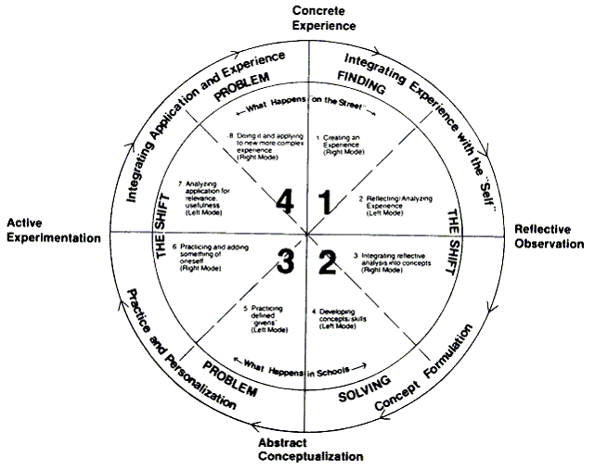
McCarthy (1980)
The 4MAT system deals with the process of problem finding and problem solving, a high level of learning. The process moves from integrating experience within the self, to practice and internalization, and, finally, to integrating application and experience.
Figure 12.8 shows the role of the teacher when going through the four phases of learning. Note that the assumption here is that the learner, although dominant in only one mode, can process information in all four modes. The role of the teacher then is to insure that the student experiences all of the dimensions given.
Figure 12.8 The teacher's role: A recapitulation
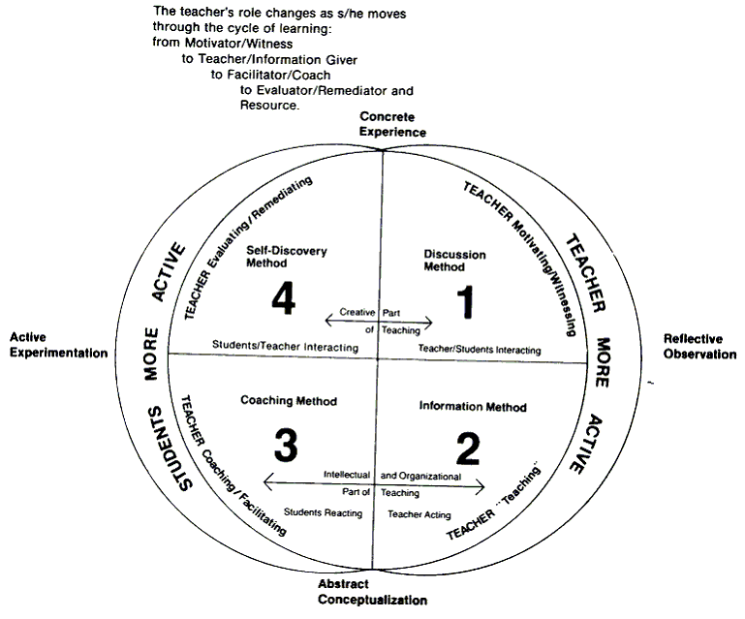
McCarthy (1980)
Developmental Implications: McCarthy's System
A number of theorists who write about cognitive styles believe that they are influenced in children by their developmental level. You will remember from chapter 6 that Piaget and others proposed and showed evidence for changes in learning as children mature through successive stages.
Figure 12.9 shows the Piagetian developmental ladder and compares it to the McCarthy spiral, which looks at the development of complexity in the behavioral, symbolic, affective, and perceptual areas.
Figure 12.9 The ladder and the spiral
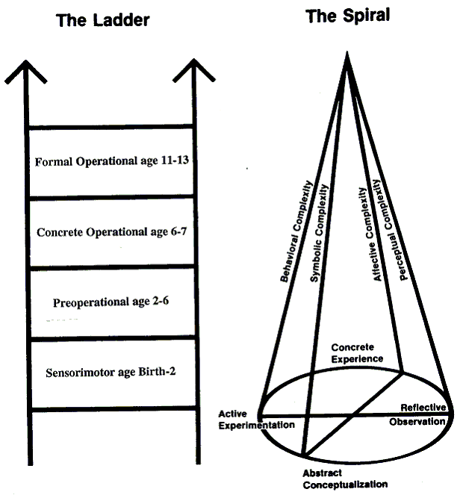
McCarthy (1980)
This complexity develops according to the concrete experiences, reflective observation, abstract conceptualization, and active experimentation. McCarthy's figure indicates that as learners get older they are more and more capable of dealing with the various types of complexity through the four modes of learning.
Figure 12.10 combines the ladder and the spiral to show that as learners get older they become less differentiated and more able to use the abilities in the solution of complex problems.
Figure 12.10 Combining the ladder and the sprial
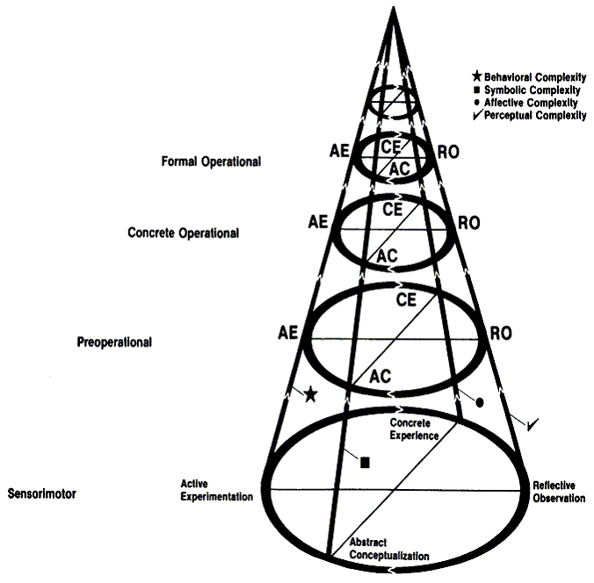
McCarthy (1980)
This indicates that the style differences between learners should decrease with age.
Other Approaches to Cognitive Style
Herrmann (1988) has developed another style model that initially looks like McCarthy's and those she has subsumed. Herrmann (1988) says that learning styles reinforce us for behaving in certain ways. We go with our strengths and avoid our weaknesses. This reinforces doing what comes naturally and leads to the dominance of one mode over others.
Herrmann's (1988) model is presented in Figure 12.11
Figure 12.11 The universe of thinking styles
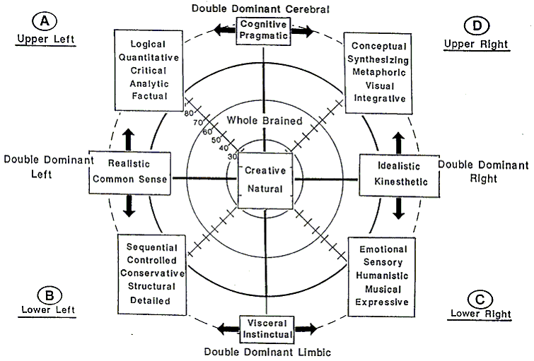
Herrmann (1988)
Note that it is very similar to that of McCarthy in terms of what goes into the four quadrants. The differences lie in the interpretation of the cerebral and limbic mode thinking processes. The cerebral mode deals with the logical and creative forms of thinking, while the limbic deals more with the emotional forms of thinking.
This in and of itself is not sufficient to differentiate this model from McCarthy's. The real difference lies in the profile that is generated by the assessment instrument. Each person who is assessed with the Herrmann instrument gets a score on the values of each quadrant. Scores in other quadrants do not adversely affect these scores. This means that a person can exhibit strengths in each quadrant, in several quadrants, one quadrant, or in no quadrant. This yields a form of style measurement that is much more like what we find in reality than that of getting a label based on one's highest quadrant score.
The Herrmann model provides for learners a profile of their strengths in the various dimensions. It provides for teachers an indicator of whether or not a learner is likely to be able to acquire information presented in a given way. For example, a student who has scored high on kinesthetic, visceral/instinctual, and realistic dimensions and low in the cognitive dimension is not a likely candidate for learning in a large class lecture. Figure 12.12 shows the ways learners from the various quadrants learn. Note that if a learner is good in two of four quadrants, then the learning mechanisms from both quadrants should be very effective in the learning setting.
Figure 12. 12 Whole brain learning and design considerations
A -- UPPER LEFT
LEARNS BY:
Acquiring and quantifying facts
Applying analysis and logic
Thinking through ideas
Building cases
Forming theoriesLEARNERS RESPOND TO:
Formalized lecture
Data based content
Financial/technical case discussions
Textbooks and bibliographies
Program learning
Behavior modification
B -- LOWER LEFT
LEARNS BY:
Organizing and structuring content
Sequencing content
Evaluating and testing theories
Acquiring skills through practice
Implementing course contentLEARNERS RESPOND TO:
Thorough planning
Sequential order
Organizational and admin. case discussions
Textbooks
Behavior modification
Program learning
Structure
Lectures
D -- UPPER RIGHT
LEARNS BY:
Taking initiative
Exploring hidden possibilities
Relying on intuition
Self discovery
Constructing concepts
Synthesizing contentLEARNERS RESPOND TO:
Spontaneity
Free flow
Experiential opportunities
Experimentation
Playfulness
Future-oriented case discussions
Visual displays
Individuality
Aesthetics
Being involved
C -- LOWER RIGHT
LEARNS BY:
Listening and sharing ideas
Integrating experiences with self
Moving and feeling
Harmonizing with the content
Emotional involvementLEARNERS RESPOND TO:
Experiential opportunities
Sensory movement
Music
People-oriented case discussions
Group interaction
Herrmann (1988) believes that what we prefer to learn is related to the style or way in which we learn and the way in which we go about learning. He says that a failure to match cognitive style to learning mode can cause frustration, increased effort expenditure, boredom, and so forth. Typically, one's learning style preference is related to one's competence, as many people are likely to do better at the things they like to do (Herrmann, 1988). However, just because you have a preference for a particular style, does not mean that you will necessarily be good at it. You may have missed out developmentally or you may have missed necessary instruction in school that would allow you to perform tasks easily within a preference domain.
Herrmann (1988) believes that everyone has access to all modes of thinking. Therefore, it is possible at anytime to learn to use information in and through a non-dominant mode. However, this is not likely without strong incentives, either internal or external. This shows that as learners we have a growth potential to learn using our non-dominant modes of thinking. Herrmann asserts that teachers should use the learner's strengths to insure that must know information is acquired, but other modes can be used effectively to challenge and stimulate the learner to exercise non-dominant practices. This helps the learner move from unidimensionality, all of one's style in a single quadrant, to multidimensionality, where the learner can acquire information using a variety of modes.
Herrmann (1988) says one's learning mode gives one a frame of reference from which to perceive the world. Those with different learning modes see the world from different perspectives. This implies that as learners change, they will change their frame of reference and, also, that learners with different strengths may need differential treatments if they are to become effective learners.
Style, Ability and Educational Structure
Learning is an internal process that is typically measured in terms of behavioral outcomes. Learning style serves as a mediational variable to explain differences among students' learning in the same instructional setting. There is a need for a mediational variable because there are affective, cognitive, and psychomotor/kinesthetic differences among learners; and these differences affect their learning preferences. There are both state (emotional arousal) and trait (ability) differences in the ability to process information, Wyer (1974). This means for learning that we must consider both of these aspects when we examine how learners learn in given contexts.
People, according to Sternberg (1990), have a variety of intellectual styles. Some they are good at and others they are less good at. Sternberg (1990) claims that the fit between the learner and the teacher is extremely important. There is also a fit problem between the way the content is taught and the way both the student and the teacher think. A teacher's style of thinking strongly influences the way in which content is taught, and the student's learning style strongly affects the way in which it is learned. When both are meshed, the student will learn at maximum potential.
Sternberg (1987) lists three functions of intelligence which look like learning options: adaptations, changes learners make in themselves to better fit the surrounding environment; environmental selection, where one changes environments to do better; and shaping, to modify the environment to make it fit better. In addition to having intelligence-related differences, there is also the problem pointed out earlier by Herrmann (1988) of preferred versus possible use.
Brodzinsky (1985) states that cognitive style deals with the way in which learners process information in the process of learning. Having a particular style does not mean that one cannot process information in other ways, for instance, reflectively rather than impulsively, but the predominance of processing will follow the preferred pattern.
Keefe (1979) puts the development of affective style as a learning style, and he is clearly in the Lewinian camp when he talks of the emotional preference of expectation as a valance. He says that the strength of a learner's action is a product of the learner's expectation of success and his/her valence or anticipated satisfaction with that success. He goes on to define affective styles as the motivational processes of arousing, directing, and sustaining behavior which determine how a learner will act. From this we can see that he believes that learning is an interactive process. This idea that learning is interactive, think back to cognitive field theory, is supported in relation to learning styles by Whitrock (1985), Iran-Nejad (1990), and Goldstein and Blackman (1978).
Interactive learning becomes important in relation to learning styles when there are alternative or multimodal presentations available. Students learn at different rates, and this difference in learning shows all should not be taught in the same way. Students also learn differently depending on whether they are novices or experts. Learning styles become important as choices in learning become available. Stylistic differences in the light of a single instructional style or format are only useful in describing the failures in the classroom. As alternatives are created, styles can be used to help develop aptitude by treatment interactions. Restak (1979) goes as far as to argue on the basis of cognitive style differences that boys and girls are different in their response modes. This is enclosed in greater female sensitivity to environmental stimuli, female attention to social cues, and so forth.
Hunt (1979) argues that in terms of styles, classroom learning environments related to cognitive styles, the one that is prominent is classroom structure. He argues that young students who have low conceptual level need a great deal of structure; but as they get older and their conceptual level increases, the need for structure is reduced. He describes the student with low conceptual level, needing much structure, as having a short attention span and a high activity level. This student is constantly on the move getting into verbal and physical arguments. Typically, this student will not work in a group or complete a problem set or worksheet. He/she tries the rules and works only when the teacher is looking. The student who needs less structure tries to solve problems himself. This student is imaginative and does not need the teacher's rewards to function. He/she is not afraid of making mistakes, seems to like to take risks, is a self-starter, and is enthusiastic about learning.
Hunt (1979) recommends that a variety of teaching strategies be used with students who need more or less structure. These are shown in Table 12.3. Note that the classroom settings would be quite different as might the learning content.
Table 12.3. The Impact of Structure Needs on Learning.
TEACHING APPROACHES WITH STUDENTS WHO REQUIRE LITTLE STRUCTURE
• Allow them to select their own seats
• Give them several topics from which to choose
• Set up weekly (or longer) assignments and allow students to set up their own timetables
• Encourage them to use each other as resources
• Allow them more mobility and give them more opportunities to take part in planning and decision making.
• Have them work in groups with the teacher serving as a resource person.
• Approach material at a more abstract of general level.
• Train them to listen to instructions
• Remind and encourage them to take an interest in others
TEACHING APPROACHES USED WITH STUDENTS WHO REQUIRE SOME STRUCTURE
• Arrange students initially in rows and gradually get them working in pairs, then in small groups
• Have definite and consistent rules—let them know what is expected of them
• Use creative drama to encourage spontaneity, self-awareness, and cooperation
• Help them to know what to do each day.
• Provide nonthreatening situations where they have to risk an opinion
• Provide a lot of praise and success-oriented situations
• Give them group problems to encourage sharing
• Provide opportunities for choice and decision making as they appear ready for them. Push them gently into situations where they have to make decisions and take responsibility.
TEACHING APPROACHES USED WITH STUDENTS WHO REQUIRE MUCH STRUCTURE
• Have definite and consistent rules—let them know what is expected of them
• Give specific guidelines and instructions (step by step), even make a chart of the steps
• Make goals and deadlines short and definite.
• Provide a variety of activities during the period. Incorporate some physical movement whenever possible
• Make positive comments about their success; give immediate feedback on each step; give much attention and assurance; praise often.
• Use pictures and things they can see tough and feel
• Get them to work immediately and change the pace often
• Display their work, it is a form of reinforcement they will like
• Capitalize on their interests to assist them in learning various reading skills
• Begin with factual material before attempting discussion
• Move gradually from seatwork to discussion, provide more group work as they are able to handle it
• Give short tests and quizzes initially
• Provide opportunities for choice and decision making as they appear to be ready for them.
Hunt (1979)
Summary
ATI's identify treatments where learners with different abilities learn differentially. Each individual has a multiplicity of abilities. The abilities that are strongest are those that should be tapped when difficult learning is approached. Treatments interact when one treatment is better for one segment of learners and another treatment is better for a different segment. Programming based on ATI's is more efficient and effective in terms of student learning.
Arousal affects learning through no amount of stimulation provided in a given learning setting. As an individual difference variable, arousal should predict low performance by both sensation seekers and sensation avoiders in any given setting. Performance takes on an inverted-U shaped curve when graphed against arousal. Those high in arousal wish to withdraw from stimulus overload. Those low in arousal need more stimulation and seek it in other areas than the learning. Hyperactivity can be interpreted in this model as a lack of ambient stimulation.
Cognitive styles refer to the various ways that a learner typically organizes, filters, transforms, and processes information. Learners are differentially prepared to learn depending on the task and the style of the learner. Cognitive styles are different from cognitive abilities as the former relates to ways in which information is processed. There are a great number of proposed cognitive styles. These include field dependence/independence, simultaneous and successive processing, focusing/scanning, reflective/impulsive, leveling/sharpening, narrow/broad categorizing, active/reflective thinking, etc.
Keefe grouped styles as attentional, receptive, expectancy/incentive, concept retention/formation, and physiological. McCarthy further collapsed style variables into two dimensions: concrete experience/abstract conceptualization and active experimentation/reflective observation. McCarthy's system allows for more complexity and higher functioning with maturity, following Piaget. Herrmann elaborates on a similar model allowing an individual to be strong in several styles at the same time or in name.
Sternberg's triarchic intelligence model is examined as a possible style model. He argues that a match between intellectual strengths and teaching approach is essential for high level learning.
Bibliography
Aptitude Treatment Interaction & Cognitive Style
Brodzinski, D. M. (1985). On the relationship between cognitive styles and cognitive structures. In E. D. Neimark, R. Delisi, & J. L. Newman, Moderators of competence (pp. 147-174). Hillsdale, NJ: Lawrence Erlbaum Associates.
Chapman, J. W., & Boersma, F. J. (1979). Learning disabilities, locus of control, and mother attitudes. Journal of Educational Psychology, 71, 250-258.
Cronbach, L. J., & Snow, R. E. (1977). Aptitude and instructional methods. New York: John Wiley.
Das (1988)
Davis, G. A. (1983). Educational Psychology. New York: Allyn & Bacon.
Donohew, L., Finn, S., & Christ, W. G. (1988). "The nature of news" revisited: The roles of affect, schemas, and cognition. In L. Donohew, H. E. Syper & E. T. Higgins (Eds.), Communication, social cognition and affect (pp. 195-217). Hillsdale, NJ: Lawrence Erlbaum & Associates.
Ferrel (1971)
Frank, B. M., & Davis, J. K. (1982). Effect of field-independent match or mismatch on a communication task. Journal of Educational Psychology, 74, 23-3 1.
Fry, & Lupart, (1987)
Garger, S., & Guild, P. (1987). Learning styles: The crucial difference. In H. F. Clarizio, R. L. Craig, & W. A. Mehrens, Contemporary issues in educational psychology (5th ed.) (pp. 173-177). New York: Random House.
Goldstein, K. M., & Blackman, S. (1978). Cognitive style: Five approaches & relevant research. New York: Wiley.
Gregorc, A. F., & Ward, H. B. (1977). Implications for learning and teaching--A new definition for individual. NASSP Bulletin, 61(406), 20-26.
Guilford, J. P. (1967). The nature of human intelligence. New York: McGraw-Hill.
Herrman, N. (1988). The creative brain. Lake Lure, NC: Brain Books.
Hunt, D. E. (1979). Learning style and student needs: An introduction to conceptual level. In NASSP (Ed.), Student learning styles: Diagnosing and describing programs (pp. 27-38). Reston, VA: Author.
Iran-Nejad, A. (1990). Active and dynamic self-regulation of learning processes. Review of Educational Research, 60(4), 573-602.
Joyce, B. & Weil, M. (1987). Models of teaching. Englewood Cliffs, NJ: Prentice-Hall.
Kagan, J. L., (1966). Impulsive and reflective children: Significance of conceptual tempo. In J. D. Krumboltz (Ed.), Learning and the educational process. Chicago: Rand McNally. (pagination)
Kagan, J. L., Pearson, L., & Welch, L. (1966). Conceptual impulsivity and inductive reasoning. Child Development, 37, 583-594.
Keefe, J. W. (1979). Learning style an overview. In National Association Secondary School Principals, Student learning styles: Diagnosing and prescribing programs (pp. 1-17). Reston, VA: Author.
Keefe, J. W. (1988). Development of the NASSP learning style profile. In J. W. Keefe (Ed.), Profiling and utilizing learning style (pp. 1-28). Reston, VA: National Association of Secondary School Principals.
Lefcourt, H. M. (1976). Locus of control: Current trends in research and theory. Hillsdale, NJ: Lawrence Erlbaum Associates.
Maran (1988)
McCarthy, B. (1980). The 4MAT system: Teaching to learning styles with right/left mode techniques. Barrington, IL: EXCEL.
McNally, R. J. (1987). Preparedness and phobias: A review. Psychological Bulletin, 101(2), 283-303.
Messer, S. (1970). Reflection-impulsivity: Stability and school failure. Journal of Educational Psychology, 61, 487-490.
Messick, S. & Associates. (1964). Individuality in learning. San Francisco: Jossey-Bass. (need other authors)
Restak, (1979). The other difference between boys and girls. In National Association Secondary School Principals, Student learning styles: Diagnosing and prescribing programs (pp. 75-80). Reston, VA: Author. (need author ini.)
Singer, R. N. (1978). Motor skills and learning strategies. In H. F. O'Neil Jr. (Ed.), Learning Strategies (pp. 79-106). New York: Academic Press.
Sternberg, R. J. (1987). The triarchic theory of human intelligence. In J. T. E. Richardson, M. W. Eysenck, & D. W. Piper (Eds.), Student learning: Research in education and cognitive psychology (pp. 49-65). Milton Keynes, England: Open University Press.
Sternberg, R. J. (1990). Intellectual styles: Theory and classroom applications. Learning and thinking styles: Classroom interaction (pp. 18-42). Washington, DC: NEA.
Weiner, B. (1982). Speculations regarding the role of affect in guiding achievement change programs guided by attributional principles. In J. M. Levine & M. C. Wang (Eds.), Teacher and student perceptions. Hillsdale, NJ: Lawrence Erlbaum Associates. (paginate)
West, C. K., Farmer, J. A., Wolf, P. M. (1991). Instructional design: Implications from cognitive science. Englewood Cliffs, NJ: Prentice-Hall.
Wittrock, M. (1985). Learning science by generating new conceptions form old ideas. In L. H. T. West & A. L. Pines (Eds.), Cognitive structure and conceptual change. Orlando, FL: Academic Press.
Wingfield, A. (1979). Human learning and memory. New York: Harper & Row.
Witkin, H. A., & Goodenough, D. R. (1981). Cognitive styles: Essence and origins. New York: International Universities Press.
Witkin, H. A., Moore, C. A., Goodenough, D. R., & Cox, P. W. (1977). Field-dependent and field-independent cognitive styles and their educational implications. Review of Educational Research, 47, 1-64.
Wyer, R. S. (1974). Cognitive organization and change: An information processing approach. Potomac, MD: Lawrence Erlbaum Associates.
Zuckerman, M. (1979). Sensation seeking: Beyond the optimal level of arousal. Hillsdale, NJ: Lawrence Erlbaum Associates.
Discussion Questions
1. Almost all aptitudes are normally distributed. Agree or Disagree? Implications?
2. Most learning theorists do not look at individual differences because learners, like laboratory animals, are supposed to be equally interchangeable. Agree or Disagree? Implications?
3. The ability to learn cannot be identified with the ability known as intelligence. Agree or Disagree? Implications?
4. There is no such thing as a general unitary learning ability. Agree or Disagree? Implications?
5. ATI's are necessary to justify all of the various models of teaching. Agree or Disagree? Implications?
6. If you do not believe that all students should be successful in a class, then you should not use ATI's in the classroom. Agree or Disagree? Implications?
7. People who have high needs for stimulation cannot be taught in conventional classrooms. Agree or Disagree? Implications?
8. When teacher raise students' anxiety level, they doom a certain proportion of them to failure. Agree or Disagree? Implications?
9. Students who are in either tail of the sensation-seeking dimension are likely to garner labels. Agree or Disagree? Implications?
10. An individual's cognitive style determines how and in what ways a learner will learn. Agree or Disagree? Implications?
11. Learning styles, cognitive styles, and affective styles are all labels for the same thing. Agree or Disagree? Implications?
12. The impulsivity/reflectivity dimension ignores the best learner, the fast accurate one. Agree or Disagree? Implications?
13. In some societies concrete thinkers would be more valued than abstract thinkers; therefore, concrete thinkers would have better self-concepts. Agree or Disagree? Implications?
14. Field independence is a desired state developmentally and in a natural selection sense. Agree or Disagree? Implications?
15. McCarthy's synthesis of learning styles summarizes them adequately, and other approaches should not be used. Agree or Disagree? Implications?
16. Cognitive style models should allow learners to be strong in more than one area if they are to adequately represent reality. Agree or Disagree? Implications?
17. Students and teachers should be matched on the basis of intellectual style. Agree or Disagree? Implications?
18. Worrying about learning styles is only appropriate where students have choices or where differential assignments are made to treatments. Agree or Disagree? Implications?
Revised 3/29/05

