Participant Guide

Food & Water:
Please eat a substantial breakfast or lunch before attending the challenge course. Outdoor activities often require more energy that a regular day at school or the office.

For full day challenge course programs, each participant should bring a bagged lunch unless other arrangements have been made. The program schedule will allow for a 30-minute lunch break.

Please avoid bringing sugary drinks and sodas. Also avoid cans; the openings are easy for bees to fly into. Juice boxes and plastic bottles with resealable tops are better.

Water will be provided by the challenge course staff and will be accessible to participants at all times. Water is in a cooler so the group should bring cups or bottles.

Clothing:
Each participant should dress for the course with comfort in mind, realizing that the chances are pretty good that they will be getting dirty. Here are some guidelines to follow:

- Loose fitting clothes that allow for unrestricted movement are best
- Shorts are acceptable, but realize the chance for scrapes. Avoid “short” shorts.
- Shorts with a longer inseam are recommended for those participating in high course activities.
- Keep the season in mind and bring warm layers if needed.
- Ponchos and/or raincoats are a good idea. We run our programs in all kinds of weather.

Each participant's footwear should be comfortable and suitable for the weather conditions. Shoes such as sneakers, running shoes, or light hiking boots work well. No open toed shoes or sandals.

Jewelry (including earrings) and watches should be left in the car or other safe place. The staff will not allow them to be worn on the course.

Glasses and contact lens wearers should take any precautions that they would normally take when participating in outdoor activities to protect eyes and eyewear. Wearing an eyeglass-retaining strap will help protect your glasses.

Sunscreen and bug repellent are highly recommended.

For safety reasons, tobacco, gum, and candy are not permitted on the Challenge Course site.
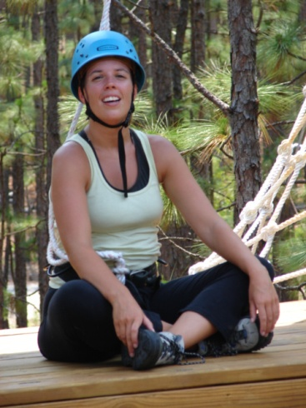

UNCW Discover Outdoor Center
General Health Information Guide

Please read this information carefully and consider the areas that may apply to you or your child. This information is intended to help you and your challenge course facilitators plan a safe and enjoyable experience for you or your child. Please remember that choices regarding limiting participation will be respected at all times.

ALLERGIC REACTIONS AND ASTHMA CONCERNS
Most Discover Outdoor Center programs are conducted in the outdoors, in the woods, or in open fields. If you have had any severe allergic reactions to environmental stimuli such as insect bites, or bee stings, pollen, grass, or other outdoor plants please let us know. Examples of severe reactions include shortness of breath, extreme itching, redness, hives, or swelling around the mouth or throat. If you carry an Epi-pen or an Epi-kit (epinephrine), please bring it with you. In addition, if you use an inhaler or any other necessary medication, be sure to bring it with you.

CARDIOVASCULAR CONCERNS
Cardiovascular concerns refer to conditions affecting the heart, or the vascular system that brings blood to the heart muscle. If after walking or light exercise you become dizzy, experience chest pain or unusual shortness of breath, or break out in a cold sweat, this could indicate a cardiac problem that would be of concern to the program. We would also like to know of you have been diagnosed with any heart conditions, e.g. angina or coronary heart disease, so we can assist in the planning of your level of participation.
ORTHOPEDIC CONCERNS
Orthopedic refers to any part of the skeletal or muscular system including the neck, back, shoulders, hips, elbows, wrists, fingers, knees, and ankles. As mentioned, Discover Outdoor Center activities can involve activities like lifting, stretching, jumping, and climbing. If you have a known condition, e.g. shoulders that easily dislocate, that might be aggravated by these kinds of activities, please let us know so we can help plan your level of participation. If you use an orthopedic device like a knee brace, please bring it with you.

YOUR GENERAL HEALTH
- Do you have diabetes?
- Have you been treated for a psychological condition, or do you have an acute, debilitating anxiety concerning heights?
- Do you have any acute or chronic medical condition?
- Do you have any concerns about the state of your health?

If you have questions or concerns, please call the Discover Outdoor Center at (910) 962-4052.

After reviewing the information, please read and complete the Assumption of Risk, Release of Liability, and Medical Information forms. Please return these forms to your course coordinator unless otherwise directed.

