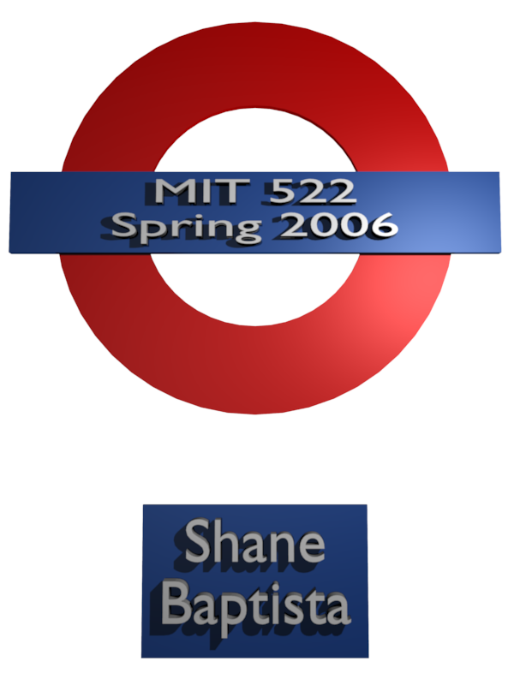
I started this course with some idea of how to put together a grant proposal. I have been involved in grant procural and administration for some years at UNCW. However, in my past grant involvement, I have been called in specifically for my technical skills. As an upshot of this I was familiar with only one portion of the grant writing process. This class helped me get a better understanding of; what a technology change plan is, who should be involved in the various stages of a technology change plan, why to write a technology change plan, how to find possible funding agencies to help with the technology change plan.
The beginning of my contribution to the project was the main idea of incorporating Open Source Software into the curriculum of an underfunded community center. I then sought input from the UNCW Office of Diversity as to whether or not there was a local underfunded community center with a need for the project and a director who would be interested in collaborating with some graduate students. After a couple of preliminary telephone conversations with the director of Girl's Incorporated on Castle Street in Wilmington we arranged to meet as a group. I introduced the director the the concept of Open Source Software and what it could do for her community center. She had been thinking about how to kick start the technology aspect of the Girl's Incorporated Mission Statement and viewed this as just the opportunity to focus on that aspect of the community center.
A couple of days after the group meeting, I met with the director again this time at the community center so that I could do an assessment of their current state of technology resources. I found four computers working and one derelict. The computers were slow and the software selection was lacking. I wrote up a full report of technical specifications for each computer and the proposed replacement computers. Later in the same vein in class I created an architectural rendering of the proposed room layout with the wall mounted monitor for training sessions.
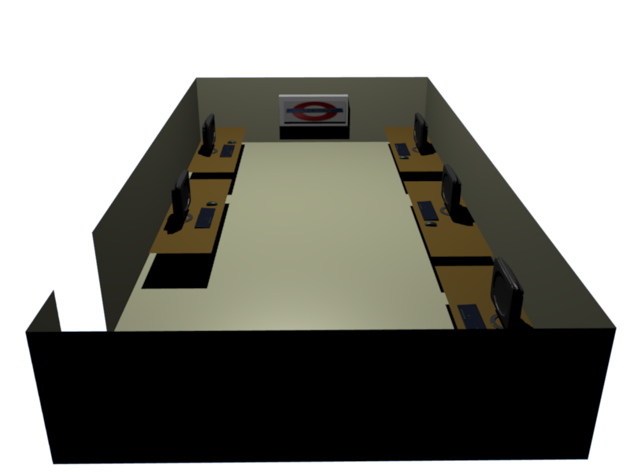
I began the project thinking of the myriad Open Source Software applications that could be incorporated into the project. After a few conversations and an assessment of what would be accomplishable in a reasonable time frame forced some narrowing of the choices to two sterling Open Source Applications:
Open Office – Open Office started life as Sun Microsystems “Star Office” When you are as big as Microsoft you don’t have to buy software from them at leas that is what Sun Microsystems though as they built an internally used office suite and then licensed that for sale and support and then created an Open Source project out of the whole thing. Star Office still exists and is the development core of Open Office. The main difference is the number of templates available at the outset. Both can import created templates.
Gnu Image Manipulation Program – The GIMP started life as a course project for a computer science student. From there it gathered a community and never looked back. This humble beginning is one of the reasons the program is so woefully named. I can think of worse names but I can’t print them here. The GIMP is currently in version 2.2.1 and is stable in Linux, Windows, and MacOSx.

Both of these programs would are high quality, regularly maintained, and directly relevant to the New Hanover County and North Carolina technology competency standards. After deciding on these two programs for the project I started looking at their respective support sites. I was happy to find that both applications have extensive documentation, including books available for purchase or for free downloads. The communities each had an active discussion board where users share problems and solutions. After digging further into the support sites I found a wealth of flash based video tutorials for free, and links to consulting companies that train users in Open Office and the GIMP. I began sorting through the tutorials that I found trying to find the best stuff. I put together a link page and was going to use that for the project but the next morning I went back to the beginning and found that I would do better to just point the center to the main support page which is clear and well documented and would be maintained regularly becuase the link page I had created realistically wasn’t going to be so well maintained three or four years out and Open Office.org is still going to be there.
The links I decided on are listed below:
- Open Office Support Site
  - http://support.openoffice.org/index.html
- Gimp Users Group
  - http://gug.sunsite.dk/
- The Official GIMP Documentation
  - ftp://ftp.gimp.org/pub/gimp/docs

The implementation plan was a fun night in class. I was useful to the group because of my previous work as a trainer. I was able to help identify the learning objectives and couch them in the correct professional terms.

As my group began putting together projects I found that I was most useful in three areas; vision regarding the Open Source resources available to the group, gathering and parsing technical data, and graphic design.

The program that I used to create the images is Blender 3D (http://www.blender3d.org). Blender itself is an Open Source tool which would be available to the community center once they acquired computers with enough oomph to handle it. At some future point, once the beginnings put forward in our project were settled it would be fun to go back in and teach some 3D modeling and animation. When putting forward the “donation in kind” for a project Blender would be awesome because the proprietary equivalencies cost from $1,500 - $7,000 per seat. Multiply them numbers out across 30 computers, $45,000 - $210,000 and the project looks well funded from the outset.
The class time spent learning how to look for grant opportunities through the COS website was a treat. The entire discussion helped me understand better what it was that we had done in the course. It was in this session that the nit-picky details made sense. The why was answered most clearly. Why? Because you would want that information too if you were to fund something and then try to tell somebody else what you had funded. My entire perspective on writing grants expanded to include those who fund. Good nights work I would say. This night had an impact on the verbiage that would come later. I began less trying to tick off check marks and more how to make each element build a coherent easy to fund whole.
In the closing phases of the class I was responsible for the graphic design and compiling the powerpoint and I contributed major textual revisions to the final document.
I enjoyed the in class meetings, and I’m glad that most of the class was handled in this manner. This being my first class, it was a chance to meet some of the students in the program. The class sessions that were held remotely through online conference were also fun but I’m not sure I would have learned as much if all the class sessions were handled that way.
I was nervous starting a class with a group project. I was alternately worried that I would pull down the other members of my group because this is my first graduate class, or that I would have to spend an inordinate amount of time fixing what might be done wrong or not at all. I have been pleaseantly suprised. I enjoyed working with my group. Each team member has contributed in equal measure and the whole project is better for the collaboration. This was a great way to learn how to apply for a grant becuase the grant proposal process itself is usually a very collaborative one.
As a group we met four times out of class and each of us took the lead in one or more portion of the assignments. We used the WebCT tools until the file size limit for attachements barred us at which point we switched to regular old e-mail and worked both asynchronously and synchronously to turn in projects on time.
We were disappointed with some of the preliminary grades for our assignments but kept cool and worked together to make the changes that were requested. We explained unclear elements of a topic within the group both during group work in class and through e-mail and threaded discussions.
I’m planning on working with Girl’s Incorporated this summer in collaboration with the UNCW Office of Diversity. I’m going to go in and clean up the computers and install what Open Source Software that I can on the tired old beasts. I’m going to propose experimenting with a Linux installation which might breathe new life into the old computers and allow the center to get up to speed with the functional goals of this project before any funding. If the center chooses to go this route it opens up a lot of educational and scientific software which will only run in a Linux Operating System. By the fall, hopefully we will have sent out at least one Grant Proposal and we’ll see where we go from there.

